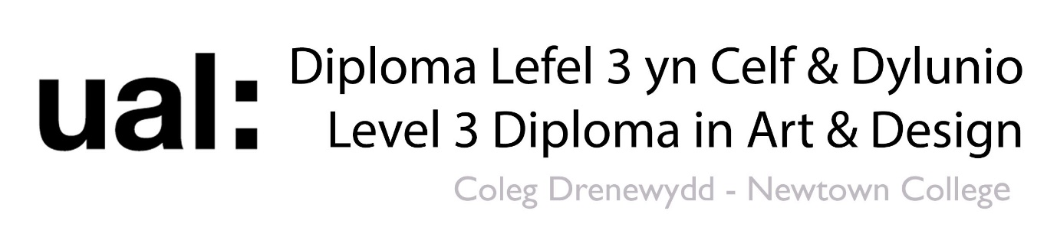
7 Deadly Sins & Heavenly Virtues
Check List
Task | Tutor | Started | Completed
Photography – Panorama | Ian
Word Cloud | Ian
Haven and Hell Planet | Ian
Photography – High Key | Ian
Photography – Low Key | Ian
Rayograms | Ian
Edited Rayograms with text | Ian
A3 Painting | Rob
Mark Making | Rob
Ink Drawing | Rob
Perspective Drawing | Rob
X2 Artist Research (Tate) | Rob
Pastel Colour Experimentation | Rob
Formal Elements | Rob
Fauvist Painting of object | Rob
Paint Application – Abstract Painting | Rob
X2 3D designers Research | Rob
Large Group Painting | Carys
X2 Portrait (1 sin & 1 virtue) | Carys
Mind Map | Carys
X3 Artist Research – Library | Carys
Lino Print (remember review notes) | Carys
Polly Board Print (remember review notes) | Carys
Multiple Drawing Exercises | Carys
Formal Elements x3 | Carys
Silk Painting | Carys
Heat Press | Carys
Art Movements x2 | Carys
Sewing | Carys
Paper Fashion | Carys
Fashion A/W 2019 - response | Carys
Fashion – Alexander McQueen S/S 2020 responce | Carys
Foam | Rob
Wire | Rob
Vacuum Form | Rob
Plastic | Rob
Cardboard | Rob
Paper | Rob
Paper Mache | Rob
Clay | Rob
Typography experiments | Chris
Typography research | Chris
REMEMBER REVIEW NOTES!!!

