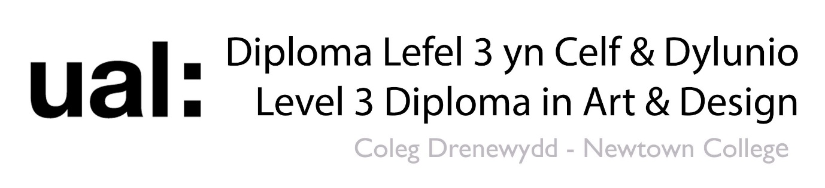

Select an Art Movement from TheArtStory.org and answer the following questions.
Name of art movement.

Name 3 artists linked to the art movement.

What kind of work were they producing? Paintings / photographs / sculpture / print making etc.

When was the art movement happening? Were there things happening at the time that influenced the work? E.g. war / civil rights / popular culture etc.

What do you like about visual aesthetics of the art work? (The way it looks).

Describe the two main formal elements in the works of the artist. Colour / line / shape / texture etc.

Describe the mood of the art work. Joyful / sinful / positive / negative / hopeful / hopeless / romantic / patriotic etc.

How have the artist created this mood using visual language? For example, have they used dark coulours to represent negative feelings? Have they used playful patterns to represent youth or childhood?

