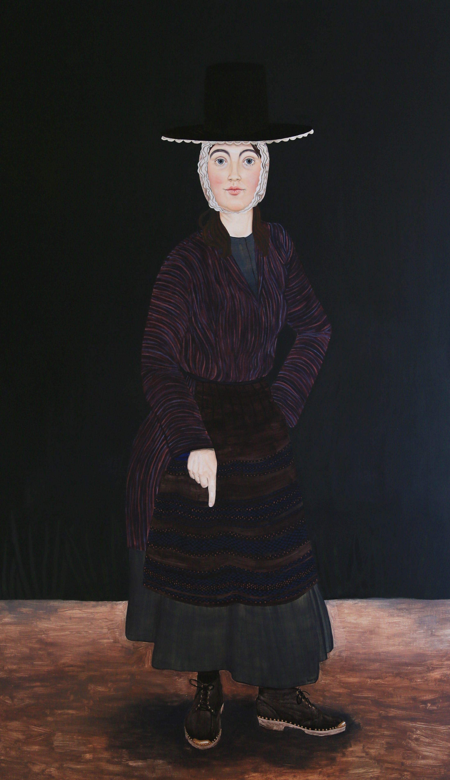

https://www.creativeboom.com/inspiration/welsh-women-and-their-past-painted-by-seren-morgan-jones/

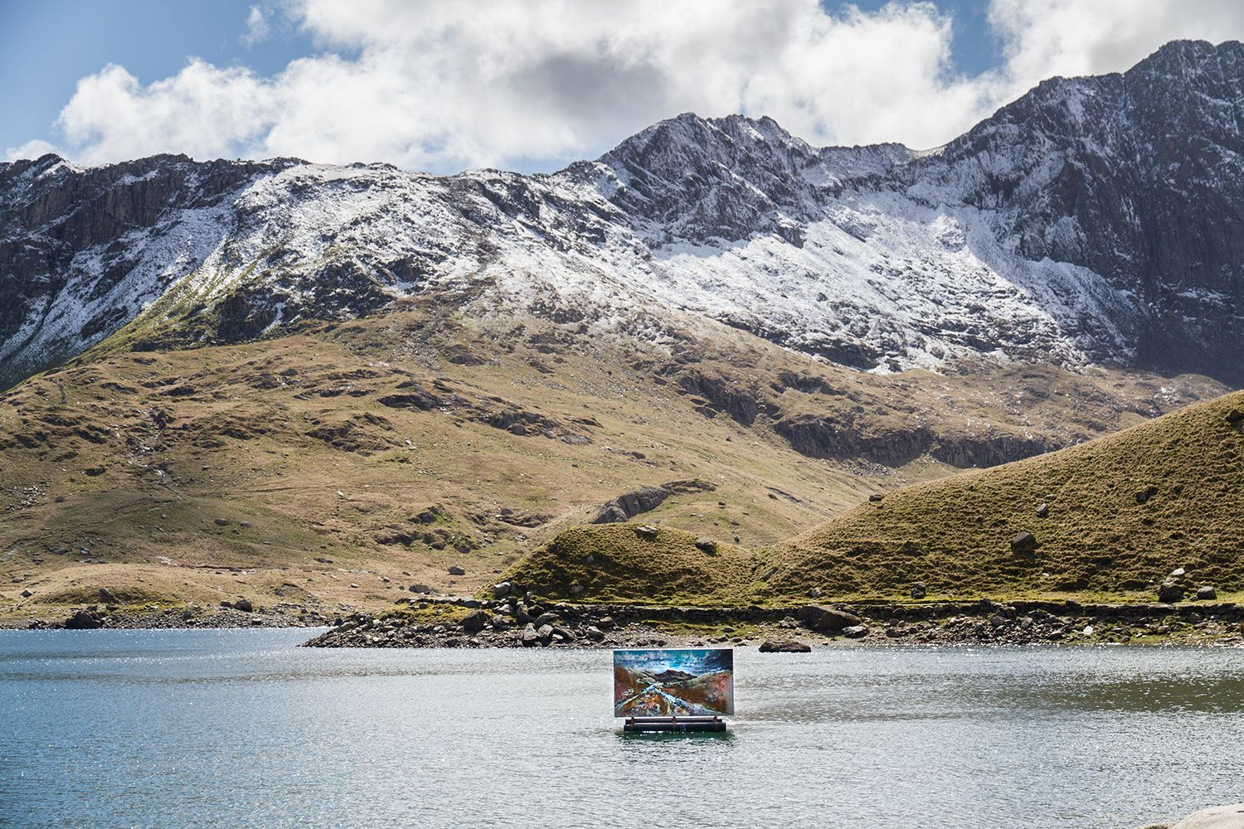

https://www.creativeboom.com/inspiration/high-and-low-stunning-photography-series-shows-off-natural-beauty-of-snowdonia-national-park/

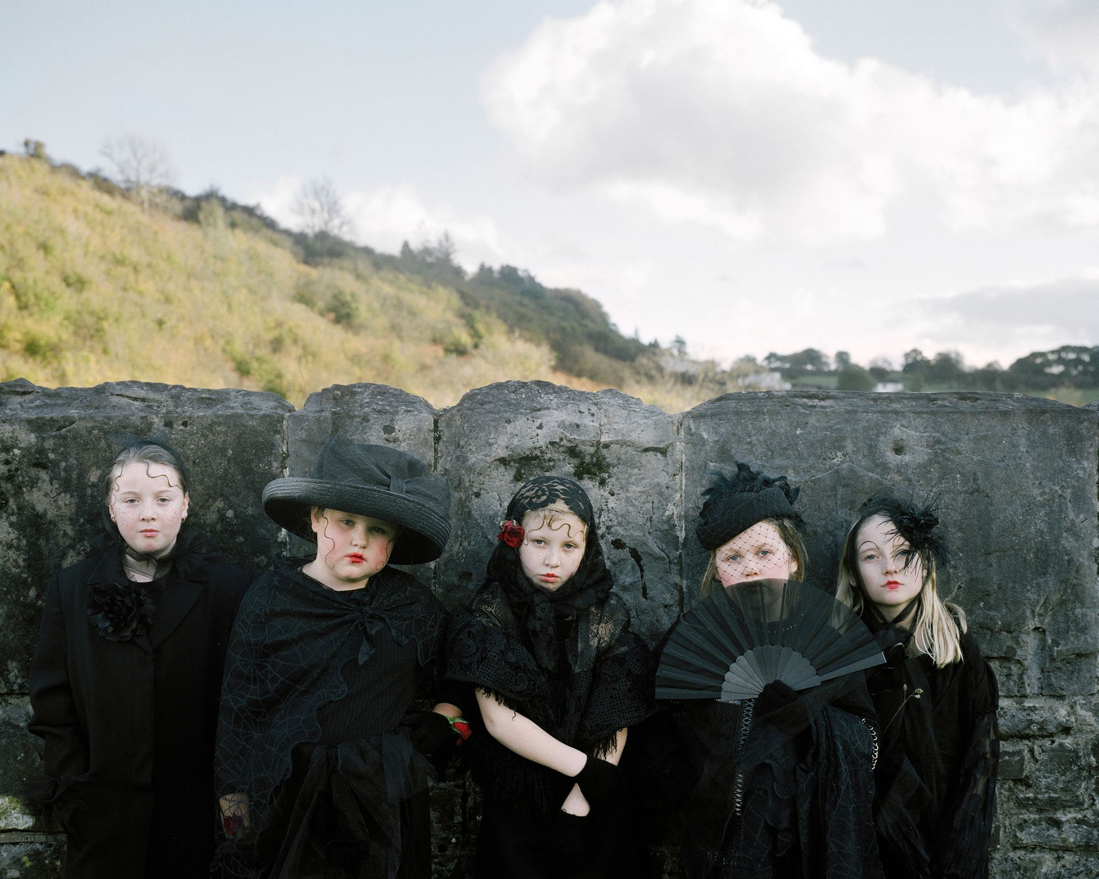
https://www.creativeboom.com/inspiration/photographs-of-children-in-costume-captured-against-the-backdrop-of-post-industrial-south-wales-valleys/
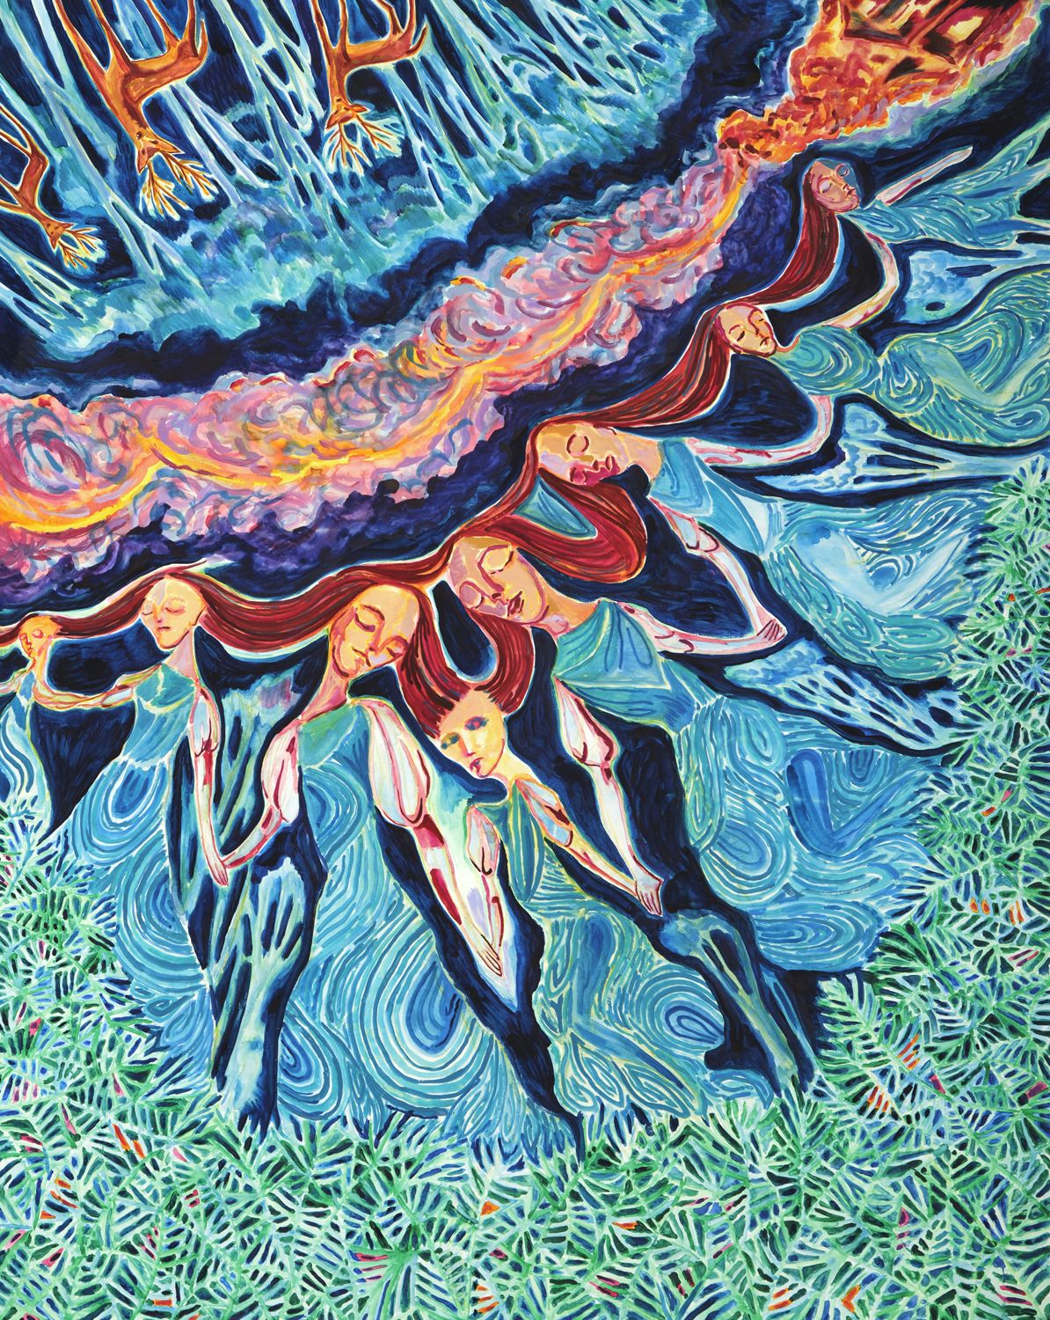
https://www.creativeboom.com/inspiration/paintings-linocuts-and-etchings-by-welsh-artist-john-abell-mark-the-180th-anniversary-of-the-rebecca-riots/

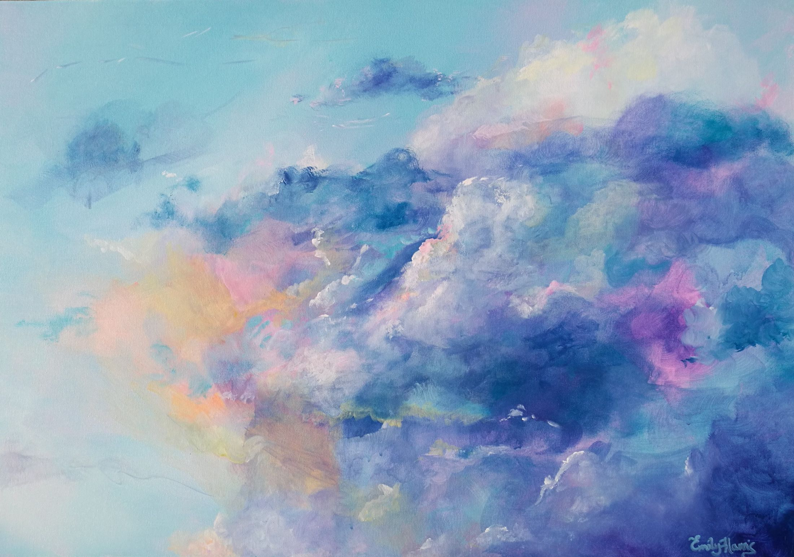
https://www.creativeboom.com/inspiration/paintings-by-emily-louise-heard-that-show-the-beauty-of-the-sky/

