NPTC Group **Art & Design Department** UAL Extended Diploma

Assignment: **Term 1: Exploratory Workshops** Start: Deadline:

Tutors: Rob Loupart, Ian Savage, Carys Jones

For this assignment you will be producing work to cover the units below:

*Unit 1: Visual language Unit 2: Research Skills*

*Unit 3: Contextual & Critical Awareness Unit 4: Materials & Processes*

**7 Deadly Sins and 7 Heavenly Virtues**

**Sin Virtue**

**Lust (excessive sexual appetites) Chastity (purity)**

**Gluttony (over-indulgence) Temperance (self-restraint)**

**Greed (avarice) Charity (giving)**

**Sloth (laziness/idleness) Diligence (integrity/hard-working)**

**Wrath (anger) Forgiveness (composure)**

**Envy (jealousy) Kindness (admiration)**

**Pride (vanity) Humility (humbleness)**

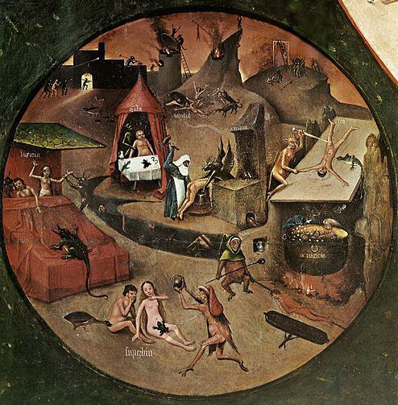 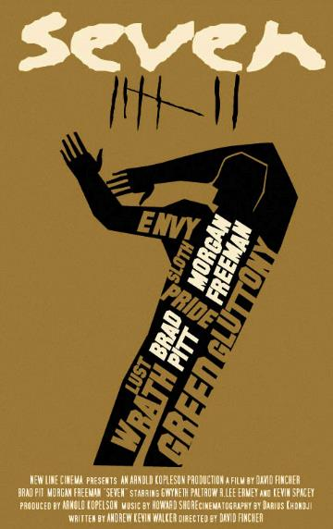



7 heavenly virtues by Emma Brabrook

**Start:** Research & Recording

Investigate various Art, Craft and Design movements covering different cultures, periods and styles, using the college library, Internet and gallery visits.

Produce A3 **and** A4/A3 journal sketchbook pages with your own sketches of the works, or of the most interesting parts, using appropriate media to help capture important colour, texture or structure.

Only use backgrounds, text and titles that reflect the movements you have studied.

Only use photocopies/print-outs, if you are going to annotate them for composition, etc or to ‘work into’ them yourself.

Analyse, in your own words, what types of work they created, the characteristics and features that make their work distinctive, the influences and context in which it was produced.

Identify how the formal elements (line, colour, tone, shape, form, structure, etc) are used in it. Explain the media/materials used and any more unusual processes or techniques. Make a note of the source website, book or journal (Harvard system).

Use sheets: *Unit 3 Contextual Influences in Art & Design. Looking at others work.*

Remember: **‘Thirds’**

At least one third drawing/sketching/collage response produced by you.

At MAXIMUM one third of EVALUATIVE notes produced by you. Typed or neatly handwritten. Not copied!!!

A MAXIMUM of one third printouts/photocopies from internet/magazines/books.

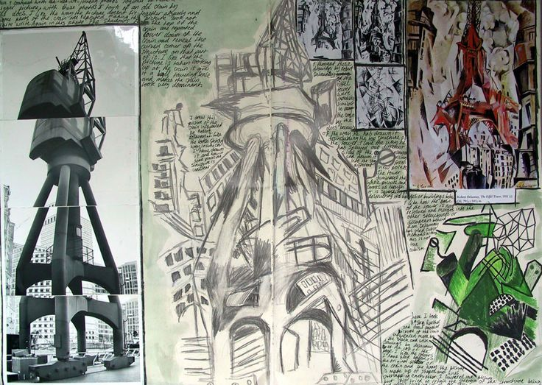 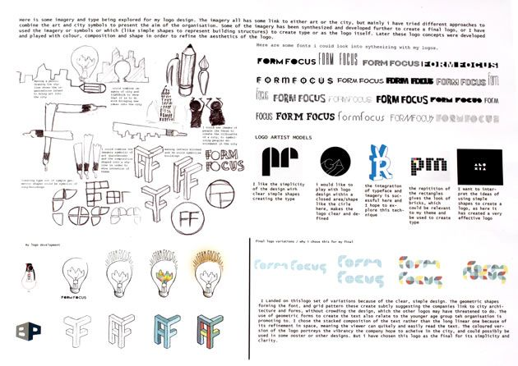

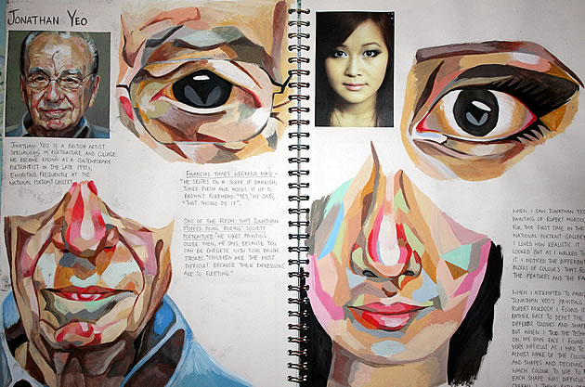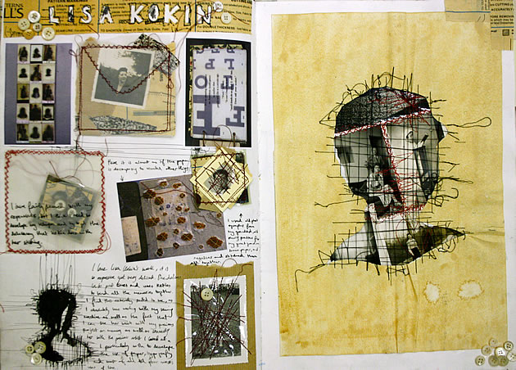

**Develop:** Exploratory Workshops:

**Photography Graphic Design Textiles 3D Design Fashion**

**Sculpture Painting Printmaking Drawing Design Crafts**

You will then be set a short brief or scenario to work in, using the relevant research and materials/processes. Some workshops will only last a few hours and some may be spread over a number of days.

Follow the brief/scenario given and produce some quick ideas to work with in a sketchbook or appropriate way. Develop these ideas while working with the material/process.

Work safely, using skill and control. You may need to make notes in

your sketchbook as you progress, about what is going well or not so well.

When you have finished the workshop, record and analyse each material or main

process used. This will help you to evaluate the suitability of materials and processes for future project work.

Keep these notes in your sketchbook, you may need to photograph/sketch your larger 3D work. Use sheets *‘Unit 2 Materials, Techniques & Processes. Experimentation Record’.*



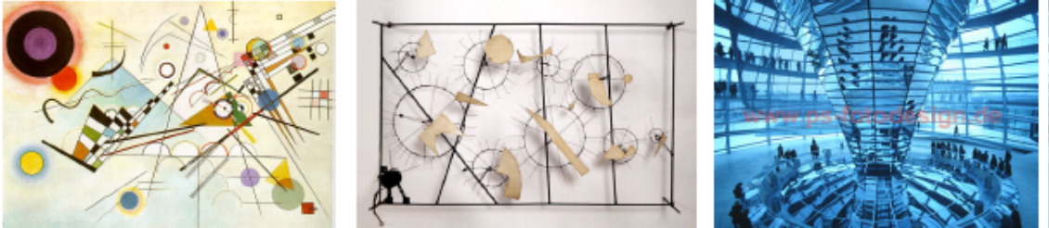

**Presentation:** Mounting, presentation & review

Throughout you will mount and present a selection of your best pieces from the exploratory stage.

Some will be wall mounted, photographed or digitally presented.

You will also critically review and evaluate your work by comparing the work you have produced in a written review, Powerpoint or Blog:

*Use of visual language (formal elements).*

*Research skills: drawing/photography of primary/secondary sources.*

*Influence from artists/designers.*

*Use of materials, techniques and processes.*

*Positives & negatives, improvements.*

