Start Date: 02/12/2019 Hand In: 24/1/2019 Duration: 6 weeks
Delivered by: Carys Jones, Rob Loupart and Ian Savage
Assessor: Carys Jones
During this project, you will be producing work for the following units:
U2 - Introduction to contextual research in art and design. U3 – Introduction to drawing skills.
U4 – Introduction to communication skills in art and design U5 – Solving 2D Creative problems
Culture
noun
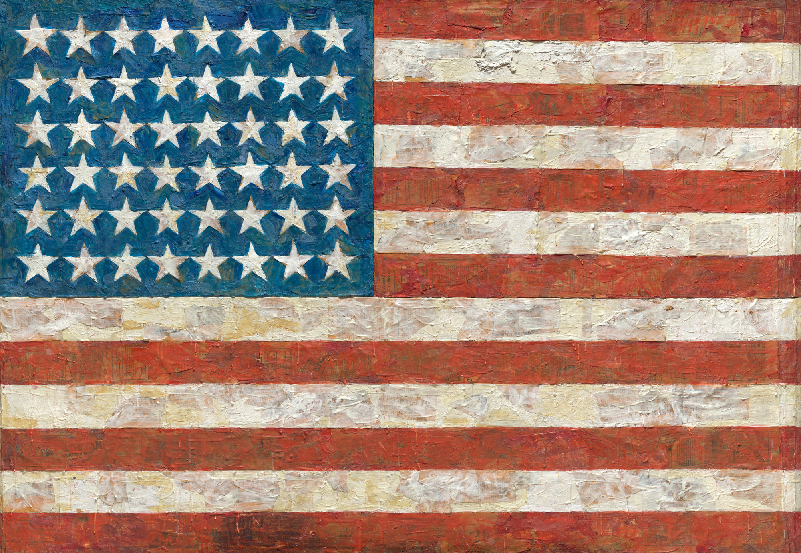
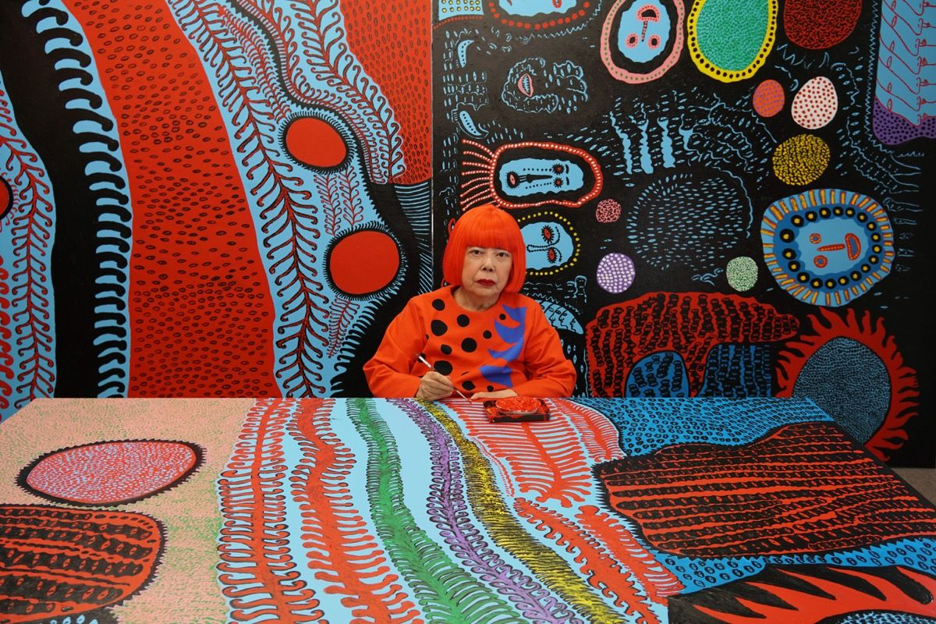
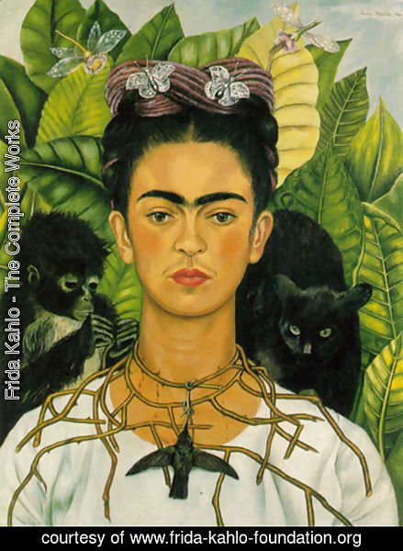
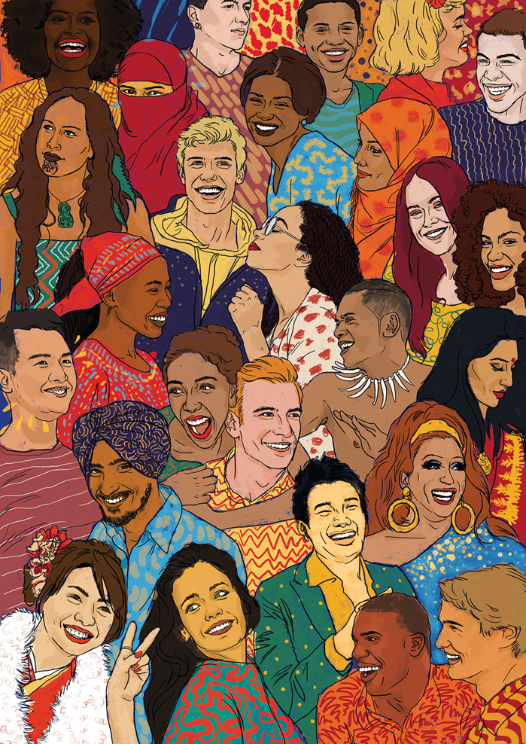
“the ideas, customs, and social behaviour of a particular people or society”

Aim
The aim of this project is to provide you with opportunities to build on the drawing, contextual research skills and practical skills you were introduced to in the previous project. You must use previously acquired skills, knowledge and understanding to work towards
You will gain an understanding of how to use your drawing and research skills to develop your ideas to solve a 2D art and design problem. You will also be introduced to the communication skills required to express your ideas and record experiences.
- Research and explore
Explore the theme ‘Culture’ through mind maps, drawing, photography and collecting textures and found objects.
You may wish to begin exploring the different types of cultures, such as geographical cultures from around the world, popular cultures such as hippies and punks, popular culture that is influenced by TV shows, music and films.
Use this as a starting point, but take it in the direction that interests you most. Record your ideas, thoughts and contextual research in your visual diary.
Use the library and the internet to demonstrate a contextual awareness. Keep up to date with current events that could influence your work. Research relevant artists and designers in order to inform and develop your ideas. What inspired them? What techniques have they used?
Keep an open mind before you establish direction. Experiment with media, techniques and scale to explore different stimulus materials.
Organise both your written and visual research.
Explore the formal elements in 2D materials, evaluating your outcomes, and using this information to develop your ideas.
Evidence: Mind map, artist/designer research presented in a visual diary or your sketchbook, notes from gallery visits, interviews with artists/designers, news clippings, photographs, A1/A2 drawings in varied medias, exploratory observational drawings, smaller sketches, collages of colours, textures and rubbings, group/peer crits etc.

- Recording to develop ideas
Complete studies of visual elements from primary and secondary sources.
Make observational drawings using a variety of media and techniques, which will be used to develop into final outcomes. Refer to your research, how did exploring others work inform your own work?
Utilise and develop your skills from the previous project when drawing, including measuring techniques as well as methods of recording light and perspective. Complete studies of visual elements from both primary and secondary sources.
Keep an A5 sketchbook and camera with you to record ideas, observational drawings and textures when you’re out and about. This will allow you to record texture, contrasting surfaces, pattern, tone and form which could be used to inform your ideas and development.
Use photography, sketches or video to record the progress of your project, annotating alongside your images to reflect upon the process.
Organise your studies into a sequence that shows the development of your ideas.
Evidence: A5 sketchbook/visual diary containing observational drawings, photographs, found objects and textural rubbings, A1/A2 drawings in varied media, annotations.
- Develop and create
You will continue to develop your knowledge and understanding of the 2D materials introduced to you in the previous projects. Towards the end of the project, you will be given time to independently use the materials, processes and technical skills acquired in the workshops to solve a 2D art and design problem.
Evidence: developing work in drawing, roughs, thumbnails, models, notes, test pieces, samples, failed work, your thoughts.
- Evaluation
Document your progress by evaluating processes, techniques and materials. Highlight any problems or successes you encountered. You can also use this time to reflect on your experiences, forming a diary of your thoughts and experiences throughout your first project.
Evidence: Sketchbook notes, tutor and peer feedback, annotated photographs, annotated drawings.
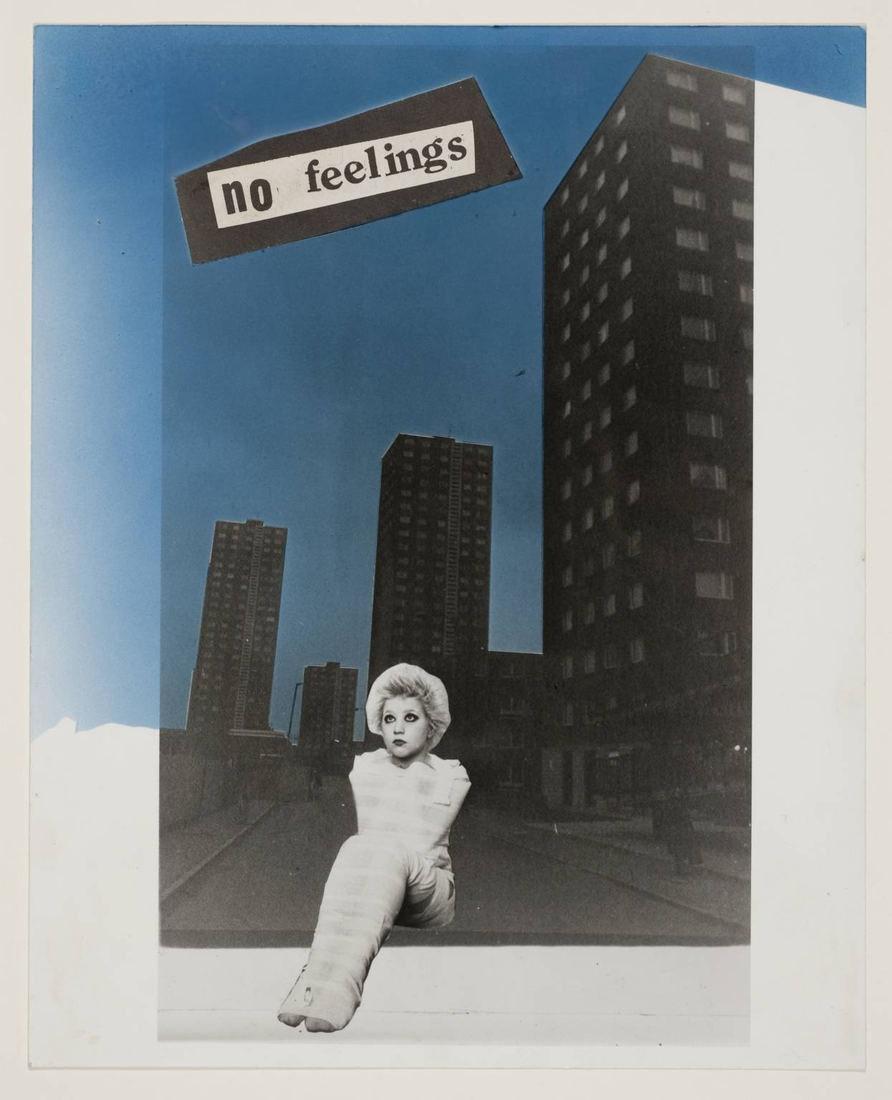
James Sparshatt
Mujer de Santiago, 2002

Jamie Reid
No Feelings
1977

