Line: 3 drawing tasks using a viewfinder to create interesting ‘abstract‘ visual outcomes.
Task 1: Half hour
Place the viewfinder on one of the organic images provided.
Using a bamboo stick with a brush taped onto the end, dip your brush in ink and enlarge the view you see through the viewfinder to FILL the A2 sheet. DO NOT SHADE. Your ‘line’ study should be detailed and accurately depict what you see through the viewfinder.
You must hold the stick at the far end to allow a line quality of freedom.
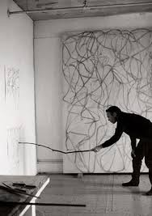

Task 2: Half hour
Change the position of the viewfinder.
Again using a stick of charcoal enlarge the view you see through the viewfinder to FILL the A2 grey sheet.
This time DO NOT take the charcoal off the grey paper AT ANY TIME.
You are creating a ‘continuous’ line drawing .
This drawing should still be detailed and accurately depict what you see through the viewfinder. Allow the properties of the charcoal to give you a variety of depth and sensitivity of line. How many ways can you find to do this?
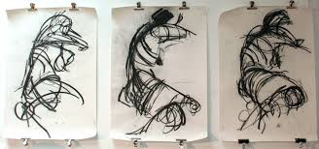

Task 3: Half hour
Change the position of the viewfinder for the third time.
Again using a marker pen enlarge the view you see through the viewfinder to FILL the A2 sheet.
Use your ‘wrong hand’ (usually the left hand) to complete the study. This will allow a quality of freedom and lack of control to the line, ensuring some interesting outcomes!
This time show MID, LIGHT and DARK tone in the study by shading using a range of mark making to create the shades. eg. Cross hatching, dots, dashes.
