3 drawing tasks using a viewfinder to create interesting abstract visual outcomes.
Task 1 Half hour
Place the viewfinder on one of the organic images provided.
Using a marker pen, enlarge the view you see through the viewfinder to FILL the A2 sheet. DO NOT SHADE. Your ‘line’ study should be detailed and accurately depict what you see trough the viewfinder.
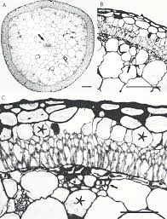

Task 2 Half hour
Change the position of the viewfinder.
Again using a marker pen enlarge the view you see through the viewfinder to FILL the A2 sheet.
This time DO NOT take the pen off the paper AT ANY TIME.
You are creating a ‘continuous’ line-drawing .
This drawing should still be detailed and accurately depict what you see through the viewfinder (but your lines will constantly overlap and will look like mistakes as you can’t take the pen off the paper).
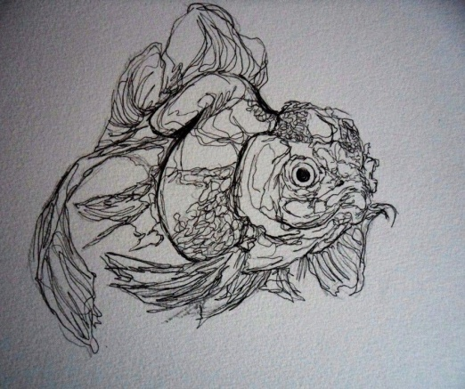

Task 3 Half hour
Change the position of the viewfinder for the third time.
Again using a marker pen enlarge the view you see through the viewfinder to FILL the A2 sheet.
This time show MID, LIGHT and DARK tone in the study by shading using a range of mark making to create the shades. eg. Cross hatching, dots, dashes.
