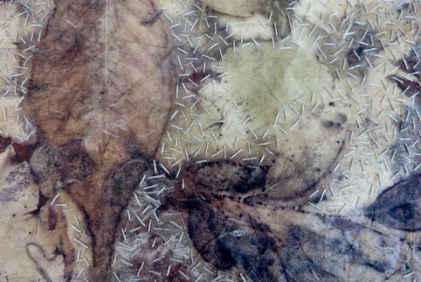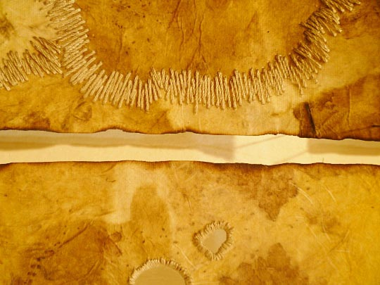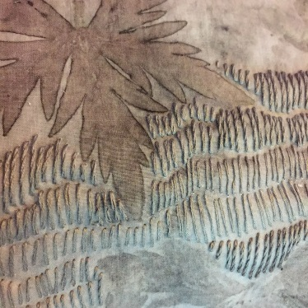
- Stitching on top of printed backgrounds.

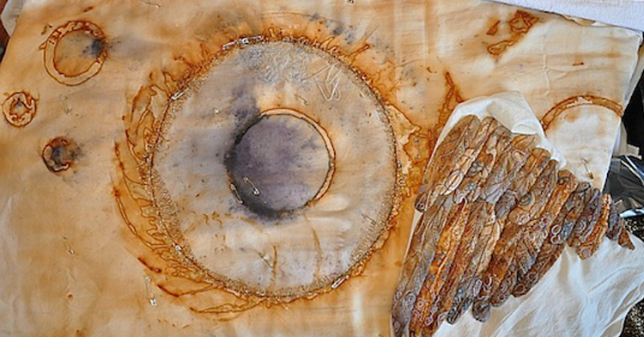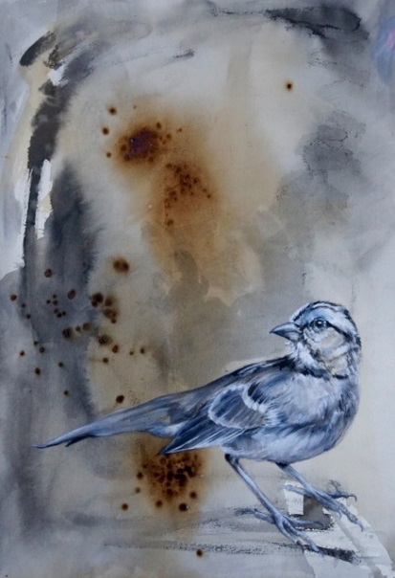
- Stitching on rust effects. Ink and wash drawing on rust effect background.

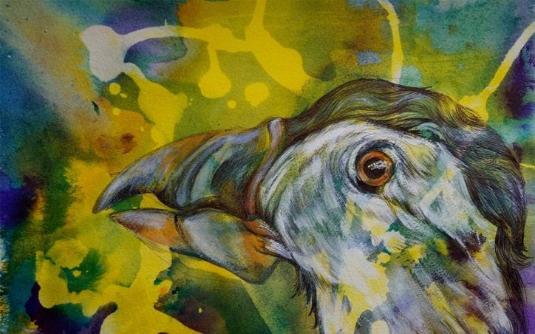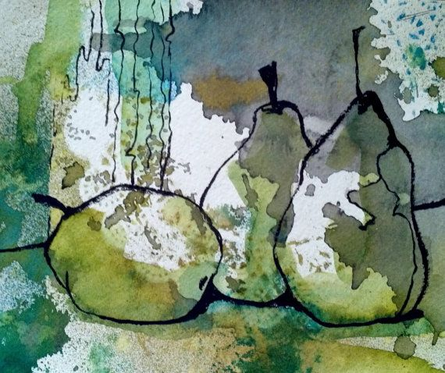
- Colour pencil study on ink wash and bleach splashed ‘Line drawn’ study of fruit over watery ink wash.
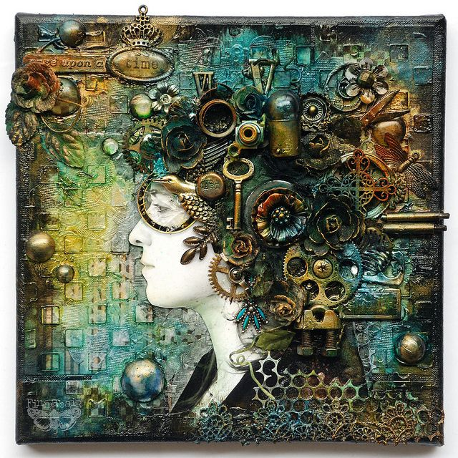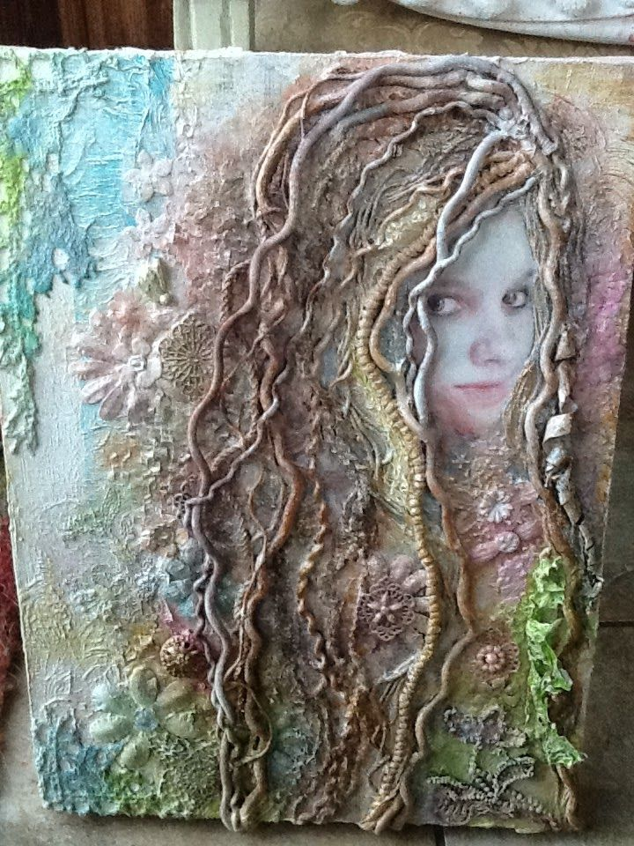
- Painted mixed media backgrounds, with collaged images of faces, and small items collaged on top (such as string , keys, brooches, material lace patterns etc)

