MIXED MEDIA EXPERIMENTS

CREATING BACKGROUNDS

* Different coloured papers to work onto.
* Different textured surfaces to work onto eg Sandpaper / Textured wallpaper / Corregated card / Torn card / Tracing paper / Brown parcel paper / Fabric / Sugar paper.

[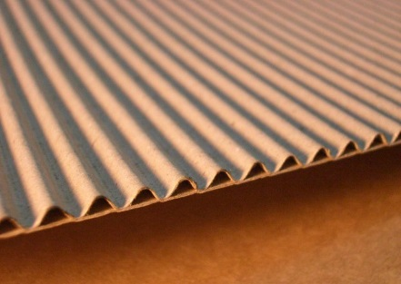](https://www.google.co.uk/url?sa=i&rct=j&q=&esrc=s&source=images&cd=&cad=rja&uact=8&ved=0ahUKEwiMn5aCnYvWAhXBoRQKHdlRCO0QjRwIBw&url=https://corkartsupplies.com/Board-And-Card/&psig=AFQjCNG67CGmwgEBblEC1sSJ3sPpUMrgLg&ust=1504604047123040) [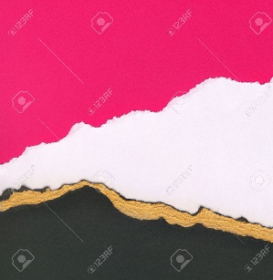](http://www.google.co.uk/url?sa=i&rct=j&q=&esrc=s&source=images&cd=&cad=rja&uact=8&ved=0ahUKEwiC4OConYvWAhVMPxQKHZClAOYQjRwIBw&url=http://www.123rf.com/photo_11582939_high-resolution-torn-card-texture-with-copy-space.html&psig=AFQjCNGxD06v2d0V1L3eGXenxYTjqe57ww&ust=1504604125662581) [](http://www.google.co.uk/url?sa=i&rct=j&q=&esrc=s&source=images&cd=&cad=rja&uact=8&ved=0ahUKEwjR_bbDnYvWAhXEzxQKHQgzA8gQjRwIBw&url=http://www.123rf.com/photo_8255159_torn-brown-card-board-paper-on-white-background.html&psig=AFQjCNGxD06v2d0V1L3eGXenxYTjqe57ww&ust=1504604125662581)

[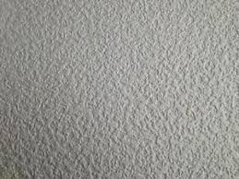](http://www.google.co.uk/url?sa=i&rct=j&q=&esrc=s&source=images&cd=&cad=rja&uact=8&ved=0ahUKEwiIs8aaoYvWAhWBWRQKHefjAOsQjRwIBw&url=http://www.ebay.co.uk/bhp/textured-wallpaper&psig=AFQjCNEwvXC596SfaeSq0NGOMUfBOlK61w&ust=1504605165009810) [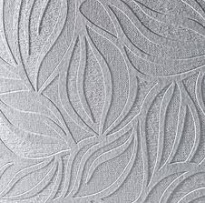](http://www.google.co.uk/url?sa=i&rct=j&q=&esrc=s&source=images&cd=&cad=rja&uact=8&ved=0ahUKEwjcqYCsoYvWAhXCOhQKHfWdA4AQjRwIBw&url=http://www.libertycakesuk.com/prepare-the-paintable-textured-wallpaper/top-paintable-textured-wallpaper/&psig=AFQjCNEwvXC596SfaeSq0NGOMUfBOlK61w&ust=1504605165009810)

* Using washes of watercolour paint onto paper and dropping salt onto areas to absorb some colour.

[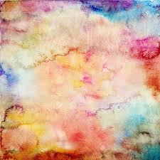](https://www.google.co.uk/imgres?imgurl=https://previews.123rf.com/images/oapril/oapril1107/oapril110700035/9862436-Textured-paper-background-in-green-and-blue-Stock-Photo-scrapbooking-paper-texture.jpg&imgrefurl=http://www.123rf.com/photo_9862436_textured-paper-background-in-green-and-blue.html&docid=3dhbhsvQyPqEdM&tbnid=xSugJnj2_37jhM:&vet=10ahUKEwiwgPaRn4vWAhXjAsAKHeEkAB84ZBAzCFUoUjBS..i&w=1300&h=1300&bih=605&biw=1360&q=textured%20paper&ved=0ahUKEwiwgPaRn4vWAhXjAsAKHeEkAB84ZBAzCFUoUjBS&iact=mrc&uact=8) [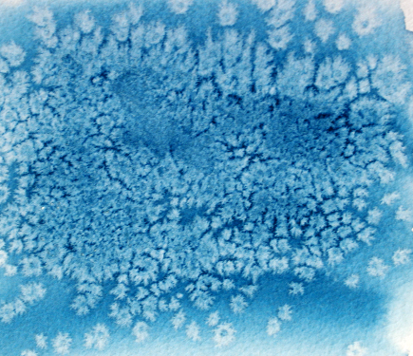](http://www.google.co.uk/url?sa=i&rct=j&q=&esrc=s&source=images&cd=&cad=rja&uact=8&ved=0ahUKEwjGn43NoYvWAhWIOhQKHS14A-YQjRwIBw&url=http://sketchbook.cheapjoes.com/2015/04/papers-and-bubbles-and-oats-oh-my/&psig=AFQjCNFIxIYTYvnM578qarSVET6KEWdk4w&ust=1504605256492284) [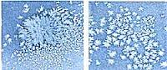](http://www.google.co.uk/url?sa=i&rct=j&q=&esrc=s&source=images&cd=&cad=rja&uact=8&ved=0ahUKEwjGjovqoYvWAhUGvhQKHSRwDeMQjRwIBw&url=http://www.nitaleland.com/faq/watercolorfaq.htm&psig=AFQjCNFIxIYTYvnM578qarSVET6KEWdk4w&ust=1504605256492284)

* Printing a large word onto a piece of paper and doing watercolour washes over the word.

[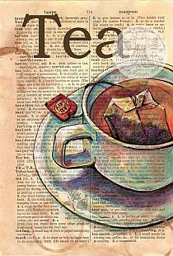](http://www.google.co.uk/url?sa=i&rct=j&q=&esrc=s&source=images&cd=&cad=rja&uact=8&ved=0ahUKEwiN-sKZsYvWAhWBXhoKHYN1A6QQjRwIBw&url=http://stylowi.pl/fryzjer/64729/kawa-czy-herbata&psig=AFQjCNF_U2bIwpt_wwNgq9C7SvMGA02WyA&ust=1504609383970002)

* Pouring watered down PVA onto surface and dropping inks onto it.

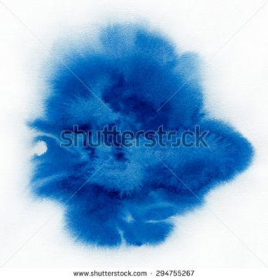 [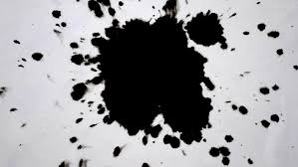](https://www.google.co.uk/imgres?imgurl=https://ak5.picdn.net/shutterstock/videos/21387919/thumb/10.jpg&imgrefurl=http://www.shutterstock.com/video/clip-2889109-stock-footage-ink-drop-drip-in-water-stock-footage.html&docid=DH0c2wDzqRS4QM&tbnid=aVLUMyPOR9PYfM:&vet=10ahUKEwi39aGcpIvWAhXpIcAKHRVSBcsQMwhuKD8wPw..i&w=852&h=480&bih=605&biw=1360&q=water%20on%20paper%20with%20ink%20droplets%20art&ved=0ahUKEwi39aGcpIvWAhXpIcAKHRVSBcsQMwhuKD8wPw&iact=mrc&uact=8)

* Drop coloured ink into water and place paper on top (marbling).

[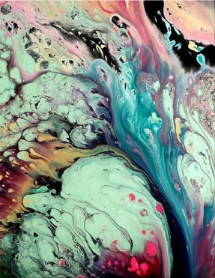](https://www.google.co.uk/url?sa=i&rct=j&q=&esrc=s&source=images&cd=&cad=rja&uact=8&ved=0ahUKEwi25cSFoovWAhUBlRQKHXAUDeYQjRwIBw&url=https://www.pinterest.com/explore/marble-painting/&psig=AFQjCNGQ2AbdM3iAs9I7f-bYRW2DW6iVBQ&ust=1504605396317692) [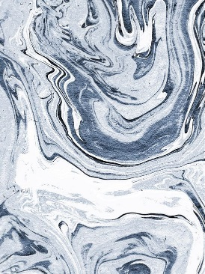](https://www.google.co.uk/url?sa=i&rct=j&q=&esrc=s&source=images&cd=&cad=rja&uact=8&ved=0ahUKEwi30pW3oovWAhUE1xQKHaYbDewQjRwIBw&url=https://www.pinterest.com/explore/paper-marbling/&psig=AFQjCNH-dQ3XIZdOya1COrKMQKlMfvpilg&ust=1504605499332445) [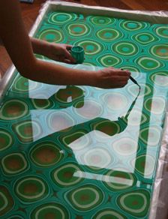](https://www.google.co.uk/url?sa=i&rct=j&q=&esrc=s&source=images&cd=&cad=rja&uact=8&ved=0ahUKEwirte_ZoovWAhVI7RQKHek6BuYQjRwIBw&url=https://www.pinterest.com/pin/503981014531109288/&psig=AFQjCNGhe7ySqTovdFreto5ovIN2wqWdEw&ust=1504605577865396) [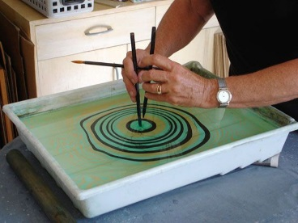](https://www.google.co.uk/url?sa=i&rct=j&q=&esrc=s&source=images&cd=&cad=rja&uact=8&ved=0ahUKEwi-_unqoovWAhVPsBQKHXsZCuMQjRwIBw&url=https://www.pinterest.com/explore/paper-marbling/&psig=AFQjCNGhe7ySqTovdFreto5ovIN2wqWdEw&ust=1504605577865396)

[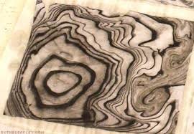](https://www.google.co.uk/imgres?imgurl=http://www.ruthbleakley.com/blog/wp-content/uploads/2013/11/Suinagashi-Troubleshooting-5.jpg&imgrefurl=http://www.ruthbleakley.com/blog/2013/11/suminagashi-marbling-tips/&docid=CtriweXUaQJlzM&tbnid=Yg7zrKLut9uFlM:&vet=10ahUKEwiAxffYoovWAhVXF8AKHT4QCQAQMwhMKBgwGA..i&w=475&h=329&bih=605&biw=1360&q=wtwe%20with%20ink%20droplets%20art%20on%20paper%20marbling&ved=0ahUKEwiAxffYoovWAhVXF8AKHT4QCQAQMwhMKBgwGA&iact=mrc&uact=8)

* Pouring watered down PVA onto surface and dropping sand onto it.

[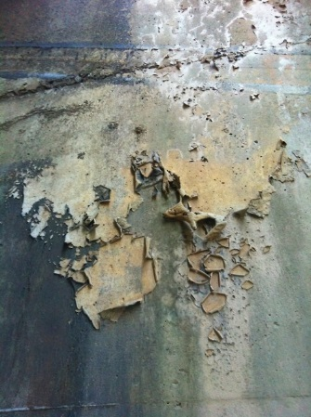](https://www.google.co.uk/url?sa=i&rct=j&q=&esrc=s&source=images&cd=&cad=rja&uact=8&ved=0ahUKEwipytGxqIvWAhXCWBQKHVTuD-sQjRwIBw&url=https://za.pinterest.com/pin/367887863289147353/&psig=AFQjCNHGH9i0b3KObAP9GMZsHDPbJ0P_tw&ust=1504607085558059)

* Pouring watered down PVA mixed with vinegar and earthy colour onto surface and dropping iron filings onto it.

[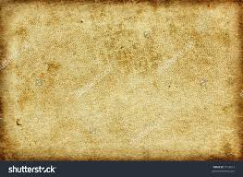](https://www.google.co.uk/imgres?imgurl=https://image.shutterstock.com/z/stock-photo-old-textured-paper-with-golden-dots-9112612.jpg&imgrefurl=http://www.shutterstock.com/pic-9112612/stock-photo-old-textured-paper-with-golden-dots.html&docid=PB0_HbkDiYwyjM&tbnid=y3Pl9l0JiVP73M:&vet=10ahUKEwj-jsSLn4vWAhVCDcAKHc3ODgUQMwjOAihIMEg..i&w=1500&h=1094&bih=605&biw=1360&q=textured%20paper&ved=0ahUKEwj-jsSLn4vWAhVCDcAKHc3ODgUQMwjOAihIMEg&iact=mrc&uact=8) [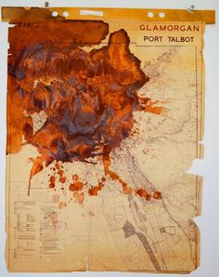](https://www.google.co.uk/url?sa=i&rct=j&q=&esrc=s&source=images&cd=&cad=rja&uact=8&ved=&url=https://www.pinterest.com/pin/287174913712919171/&psig=AFQjCNGU3u7JVVRika5nQaco6sDVm52v6A&ust=1504610730458034) [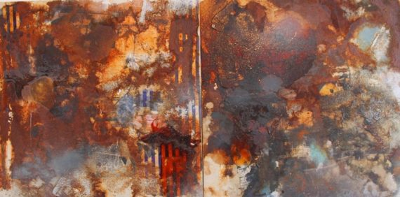](https://www.google.co.uk/url?sa=i&rct=j&q=&esrc=s&source=images&cd=&cad=rja&uact=8&ved=0ahUKEwig78uHtovWAhVIDxoKHe0JDKkQjRwIBw&url=https://www.a-n.co.uk/news/events-architecture-and-the-body-heavy-industry-and-a-new-collective&psig=AFQjCNGU3u7JVVRika5nQaco6sDVm52v6A&ust=1504610730458034)

* Layering various torn surfaces together eg, Torn Card, Torn pages from books, Torn music manuscript paper, Torn tissue paper, Torn wallpaper, Torn grades of a colour,

[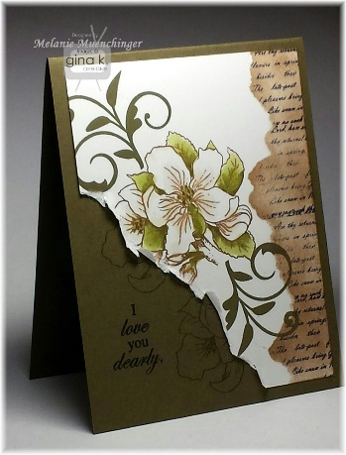](https://www.google.co.uk/url?sa=i&rct=j&q=&esrc=s&source=images&cd=&cad=rja&uact=8&ved=0ahUKEwijuMP_nYvWAhVI6RQKHV9LBOkQjRwIBw&url=https://www.youtube.com/watch?v%3DYqCeuoH1dLU&psig=AFQjCNGxD06v2d0V1L3eGXenxYTjqe57ww&ust=1504604125662581) [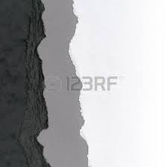](http://www.google.co.uk/url?sa=i&rct=j&q=&esrc=s&source=images&cd=&cad=rja&uact=8&ved=0ahUKEwjI3diRnovWAhUCyRQKHQdnC-QQjRwIBw&url=http://www.123rf.com/photo_11586877_useful-torn-card-texture-with-copy-space.html&psig=AFQjCNGxD06v2d0V1L3eGXenxYTjqe57ww&ust=1504604125662581) [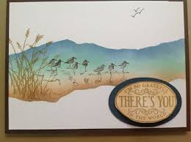](https://www.google.co.uk/url?sa=i&rct=j&q=&esrc=s&source=images&cd=&cad=rja&uact=8&ved=0ahUKEwiAgYSvnovWAhVJcRQKHUvJC-sQjRwIBw&url=https://www.pinterest.com/stampwithsandy/wetlands-stampin-up/&psig=AFQjCNGxD06v2d0V1L3eGXenxYTjqe57ww&ust=1504604125662581)

* Crinkled crepe paper / tracing paper / tissue paper / foil

[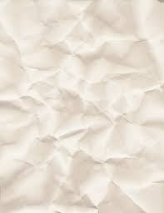](https://www.google.co.uk/url?sa=i&rct=j&q=&esrc=s&source=images&cd=&cad=rja&uact=8&ved=0ahUKEwiott-Un4vWAhWMOxQKHQOJAuwQjRwIBw&url=https://inspirationhut.net/design-resources/designer-must-haves-free-high-resolution-paper-textures/&psig=AFQjCNFbJeB0IcFlQwZTH99VaLBJpqsozQ&ust=1504604610013184) [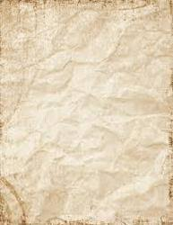](https://www.google.co.uk/imgres?imgurl=https://3.imimg.com/data3/NU/BO/MY-1745938/textured-paper-250x250.jpg&imgrefurl=https://dir.indiamart.com/delhi/textured-paper.html&docid=oGSl_AlEUSxc8M&tbnid=DA_hCeWbqgqjlM:&vet=10ahUKEwj-jsSLn4vWAhVCDcAKHc3ODgUQMwjNAihHMEc..i&w=193&h=250&bih=605&biw=1360&q=textured%20paper&ved=0ahUKEwj-jsSLn4vWAhVCDcAKHc3ODgUQMwjNAihHMEc&iact=mrc&uact=8) [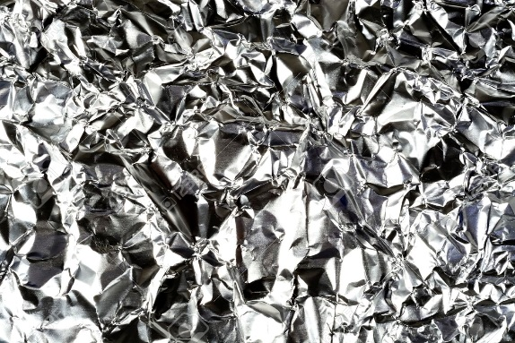](https://www.google.co.uk/url?sa=i&rct=j&q=&esrc=s&source=images&cd=&cad=rja&uact=8&ved=0ahUKEwi--LaStYvWAhXE7BQKHduIAukQjRwIBw&url=https://www.123rf.com/photo_32952038_crinkled-tinfoil-aluminum-foil-wrinkled-aluminum-foil-photo.html&psig=AFQjCNGWKEXX4XIR3JW6yhfZZ7YoSpYJYA&ust=1504610498673874)

* Textures / crinkled surfaces with washes of colour / effects on top.

[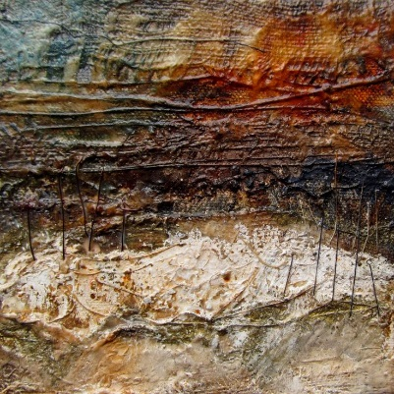](https://www.google.co.uk/url?sa=i&rct=j&q=&esrc=s&source=images&cd=&cad=rja&uact=8&ved=0ahUKEwj36MTOs4vWAhWCVRQKHUMQAesQjRwIBw&url=https://www.pinterest.com/bekivaile/burnt/&psig=AFQjCNH51FAhYo8FqkdWWOq8QuKaG7TwRw&ust=1504609814599186)

* Textured rubbings using Lead pencil / Colour pencils / Pastels / Crayons / Charcoal eg Tree bark / Coins / Leaves etc

[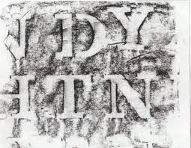](https://www.google.co.uk/imgres?imgurl=http://elonka.com/kryptos/rubbings/images/ndy.jpg&imgrefurl=http://elonka.com/kryptos/rubbings/images1.html&docid=GzGdjrIOV8NicM&tbnid=SAaDnjMESL-xIM:&vet=10ahUKEwikyPfApIvWAhUFI8AKHRGsDzE4ZBAzCC4oLDAs..i&w=644&h=500&bih=605&biw=1360&q=rubbings&ved=0ahUKEwikyPfApIvWAhUFI8AKHRGsDzE4ZBAzCC4oLDAs&iact=mrc&uact=8) [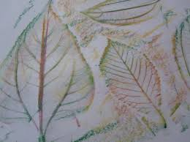](https://www.google.co.uk/imgres?imgurl=https://www.notimeforflashcards.com/wp-content/uploads/2010/10/121.jpg&imgrefurl=https://www.notimeforflashcards.com/2010/10/leaf-rubbing-tree.html&docid=Ql36rzlQc4bzJM&tbnid=jCv8Mg5QDXlyMM:&vet=10ahUKEwikyPfApIvWAhUFI8AKHRGsDzE4ZBAzCFgoVjBW..i&w=450&h=337&bih=605&biw=1360&q=rubbings&ved=0ahUKEwikyPfApIvWAhUFI8AKHRGsDzE4ZBAzCFgoVjBW&iact=mrc&uact=8) [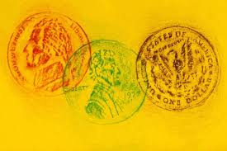](https://www.google.co.uk/imgres?imgurl=http://childrensmuseumofphoenix.org/wp-content/uploads/2017/04/Coin-Rubbings-002.jpg?x80507&imgrefurl=http://childrensmuseumofphoenix.org/events/giant-coin-rubbings/&docid=qELU_dXj4zBLbM&tbnid=DnBLKtb7PqOsAM:&vet=10ahUKEwjr2pX3pIvWAhXHC8AKHbliC1wQMwhsKD0wPQ..i&w=1387&h=923&itg=1&bih=605&biw=1360&q=rubbings%20coins&ved=0ahUKEwjr2pX3pIvWAhXHC8AKHbliC1wQMwhsKD0wPQ&iact=mrc&uact=8)

[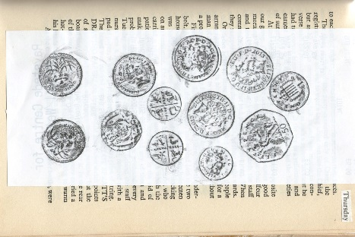](https://www.google.co.uk/url?sa=i&rct=j&q=&esrc=s&source=images&cd=&cad=rja&uact=8&ved=0ahUKEwi56d2ZpYvWAhXCQBQKHfn-CesQjRwIBw&url=https://eve512408.wordpress.com/assignment-3/research-and-reflection-part-three/other-drawings-3/&psig=AFQjCNFxLiPLI-Cp3Gbn7zcGua9yG-6qBw&ust=1504606178001128)

* Blowing bubbles in water / with soap / pva glue and ink etc, then pressing paper on the top.

[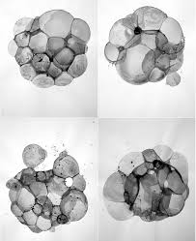](https://www.google.co.uk/imgres?imgurl=https://i.pinimg.com/736x/97/3d/1b/973d1bec16290863f2b1028da209ce97--bubble-painting-bubble-art.jpg&imgrefurl=https://www.pinterest.com/explore/water-art/&docid=x0W4M5w5puFErM&tbnid=3F24eDk0sZ3tjM:&vet=10ahUKEwizh-S3o4vWAhVFLMAKHRw2BRcQMwhFKBYwFg..i&w=724&h=887&bih=605&biw=1360&q=water%20on%20paper%20with%20ink%20droplets%20art&ved=0ahUKEwizh-S3o4vWAhVFLMAKHRw2BRcQMwhFKBYwFg&iact=mrc&uact=8) [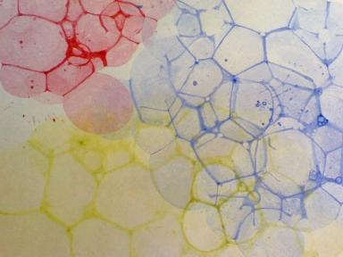](https://www.google.co.uk/url?sa=i&rct=j&q=&esrc=s&source=images&cd=&cad=rja&uact=8&ved=0ahUKEwiiqZPPsYvWAhUHRhQKHT36CegQjRwIBw&url=https://www.pinterest.com/pin/483503709975430101/&psig=AFQjCNHGJI5yUveFBPIZcbPphb3HvSyZPg&ust=1504609562873038) 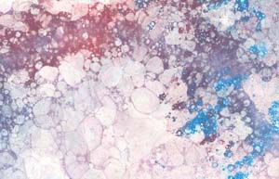

* Burning into sufaces eg Burning part of a photograph.

[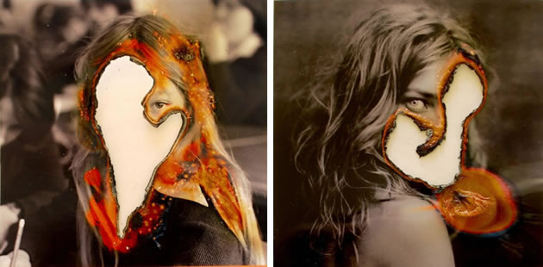](https://www.google.co.uk/url?sa=i&rct=j&q=&esrc=s&source=images&cd=&cad=rja&uact=8&ved=0ahUKEwiIsMObsovWAhXIVxQKHds6C-0QjRwIBw&url=https://www.pinterest.com/pin/305330049717706907/&psig=AFQjCNE5e5gsuWKP3cCp5tRHYVERqrYxfw&ust=1504609704910922) [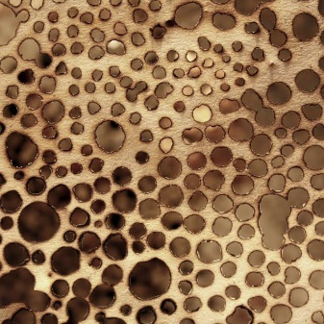](https://www.google.co.uk/url?sa=i&rct=j&q=&esrc=s&source=images&cd=&cad=rja&uact=8&ved=0ahUKEwjlsPCYs4vWAhWD8RQKHSauAuQQjRwIBw&url=https://www.pinterest.com/bekivaile/burnt/&psig=AFQjCNH51FAhYo8FqkdWWOq8QuKaG7TwRw&ust=1504609814599186)

* Burnt edges and layering.

[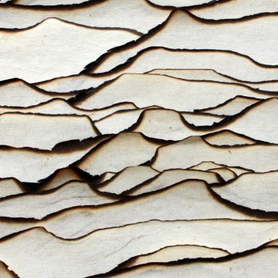](https://www.google.co.uk/url?sa=i&rct=j&q=&esrc=s&source=images&cd=&cad=rja&uact=8&ved=0ahUKEwjHwZTVsovWAhXE7xQKHc-ZC-YQjRwIBw&url=https://www.pinterest.com/aislingdoyle199/burn/&psig=AFQjCNH51FAhYo8FqkdWWOq8QuKaG7TwRw&ust=1504609814599186) [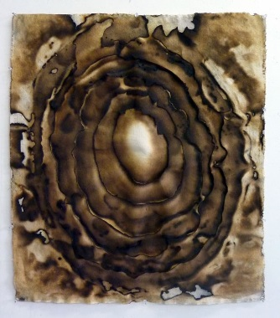](https://www.google.co.uk/url?sa=i&rct=j&q=&esrc=s&source=images&cd=&cad=rja&uact=8&ved=0ahUKEwiM9PXosovWAhXGwBQKHcSmCucQjRwIBw&url=https://www.pinterest.com/bekivaile/burnt/&psig=AFQjCNH51FAhYo8FqkdWWOq8QuKaG7TwRw&ust=1504609814599186) [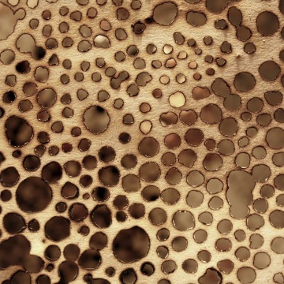](https://www.google.co.uk/url?sa=i&rct=j&q=&esrc=s&source=images&cd=&cad=rja&uact=8&ved=0ahUKEwjlsPCYs4vWAhWD8RQKHSauAuQQjRwIBw&url=https://www.pinterest.com/bekivaile/burnt/&psig=AFQjCNH51FAhYo8FqkdWWOq8QuKaG7TwRw&ust=1504609814599186)

* A faintly printed word / image appearing through washes of colour / other effects.

[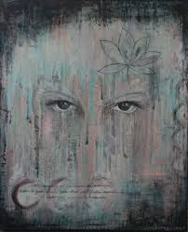](https://www.google.co.uk/url?sa=i&rct=j&q=&esrc=s&source=images&cd=&cad=rja&uact=8&ved=0ahUKEwjF88err4vWAhWCWBoKHfzqA5kQjRwIBw&url=https://www.pinterest.com/moniccx/jenny-grant/&psig=AFQjCNE0zA4WSrefgKRKv2pZoZcsMCWUMg&ust=1504608886648889) [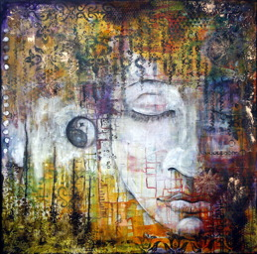](http://dst15js82dk7j.cloudfront.net/28913/46554536-KS9X7.jpg) [](http://www.google.co.uk/url?sa=i&rct=j&q=&esrc=s&source=images&cd=&cad=rja&uact=8&ved=0ahUKEwiN-sKZsYvWAhWBXhoKHYN1A6QQjRwIBw&url=http://stylowi.pl/fryzjer/64729/kawa-czy-herbata&psig=AFQjCNF_U2bIwpt_wwNgq9C7SvMGA02WyA&ust=1504609383970002)

* Use of tea and coffee staining to create backgrounds.

[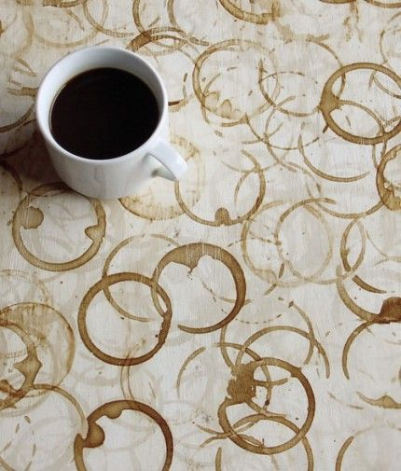](https://www.google.co.uk/url?sa=i&rct=j&q=&esrc=s&source=images&cd=&cad=rja&uact=8&ved=0ahUKEwjUkd-7tIvWAhVCiRoKHViACagQjRwIBw&url=https://www.pinterest.com/explore/coffee-art/&psig=AFQjCNHpYQWI1HjyR79YSCTIzW-IUK5JeA&ust=1504610279254596) [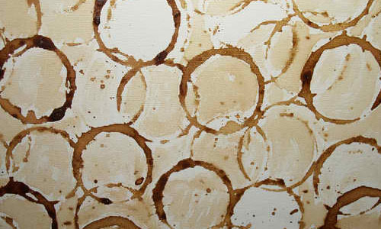](http://www.google.co.uk/url?sa=i&rct=j&q=&esrc=s&source=images&cd=&cad=rja&uact=8&ved=0ahUKEwjUkd-7tIvWAhVCiRoKHViACagQjRwIBw&url=http://naldzgraphics.net/textures/free-stain-texture/&psig=AFQjCNHpYQWI1HjyR79YSCTIzW-IUK5JeA&ust=1504610279254596) [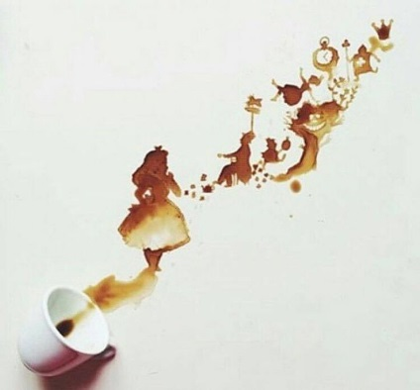](https://www.google.co.uk/url?sa=i&rct=j&q=&esrc=s&source=images&cd=&cad=rja&uact=8&ved=0ahUKEwim9bzXtIvWAhWCUhoKHSUVAp0QjRwIBw&url=https://www.pinterest.com/mistermacchiato/coffee-art/&psig=AFQjCNHpYQWI1HjyR79YSCTIzW-IUK5JeA&ust=1504610279254596)

[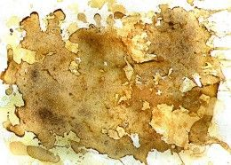](https://www.google.co.uk/url?sa=i&rct=j&q=&esrc=s&source=images&cd=&cad=rja&uact=8&ved=0ahUKEwjiksnktIvWAhVHNxQKHcJkBukQjRwIBw&url=https://www.pinterest.com/explore/coffee-staining/&psig=AFQjCNHpYQWI1HjyR79YSCTIzW-IUK5JeA&ust=1504610279254596) [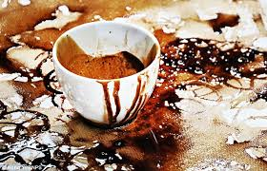](https://www.google.co.uk/imgres?imgurl=http://i.dailymail.co.uk/i/pix/2012/02/25/article-2106361-11E73B40000005DC-392_634x407.jpg&imgrefurl=http://www.dailymail.co.uk/news/article-2106361/Wake-paint-coffee-Artist-creates-portraits-using-stains-mug.html&docid=tujEff4iNeC4VM&tbnid=AbNZ1b7sYlSF3M:&vet=10ahUKEwjp6t_utIvWAhVCLcAKHaHZBTY4ZBAzCAcoBTAF..i&w=634&h=407&bih=605&biw=1360&q=tea%20and%20coffee%20stained%20art&ved=0ahUKEwjp6t_utIvWAhVCLcAKHaHZBTY4ZBAzCAcoBTAF&iact=mrc&uact=8)

* Printing with acrylics / inks mixed with pva glue etc using crumpled plastic bag / rolled rag.

[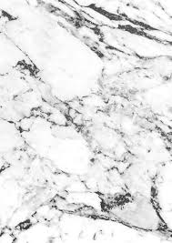](https://www.google.co.uk/imgres?imgurl=https://i.pinimg.com/736x/44/be/2e/44be2eb038b4e2580452e7b6ef56b2b3--textile-products-marble-print.jpg&imgrefurl=https://www.pinterest.co.uk/explore/marble-print/&docid=YpjwhRpxeXTwGM&tbnid=UASQstTE5QvweM:&vet=10ahUKEwjAy7bnt4vWAhWpBcAKHR-1CJg4ZBAzCAooCDAI..i&w=550&h=778&itg=1&bih=605&biw=1360&q=textured%20effects%20printing%20with%20crumpled%20plastic%20bag&ved=0ahUKEwjAy7bnt4vWAhWpBcAKHR-1CJg4ZBAzCAooCDAI&iact=mrc&uact=8) [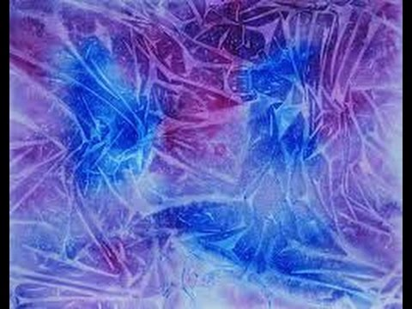](https://www.google.co.uk/url?sa=i&rct=j&q=&esrc=s&source=images&cd=&cad=rja&uact=8&ved=0ahUKEwjCr5iKuIvWAhVBWRQKHWj4BuYQjRwIBw&url=https://www.youtube.com/watch?v%3DBgDzujZMAEY&psig=AFQjCNHVYvj05bU6PvP2rh8cfuZCQsfBQQ&ust=1504611224200897) [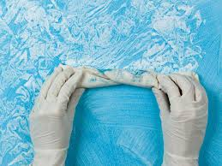](https://www.google.co.uk/imgres?imgurl=http://diy.sndimg.com/content/dam/images/diy/fullset/2011/2/24/33/RX-DK-DIY292016_rag-rolling_s4x3.jpg.rend.hgtvcom.1280.960.suffix/1420851684509.jpeg&imgrefurl=http://www.diynetwork.com/how-to/skills-and-know-how/painting/how-to-create-decorative-paint-techniques&docid=y1oeO9o3bj5gaM&tbnid=yriwGplXDsPsNM:&vet=10ahUKEwjwxK_dt4vWAhVQF8AKHbn3BpwQMwhkKDUwNQ..i&w=1280&h=960&bih=605&biw=1360&q=textured%20effects%20printing%20with%20crumpled%20plastic%20bag&ved=0ahUKEwjwxK_dt4vWAhVQF8AKHbn3BpwQMwhkKDUwNQ&iact=mrc&uact=8)

* Printing background with items such as leaves / feathers /

[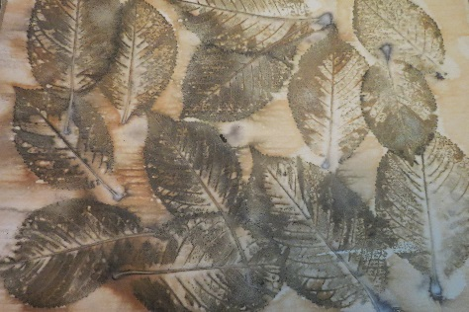](https://www.google.co.uk/url?sa=i&rct=j&q=&esrc=s&source=images&cd=&cad=rja&uact=8&ved=0ahUKEwilssrjyIvWAhUSrRQKHbtODucQjRwIBw&url=https://carolinebelltextiles.wordpress.com/tag/common/&psig=AFQjCNGrUxlNUTc7mha8im9rzR3mFcnQrA&ust=1504615795499810) [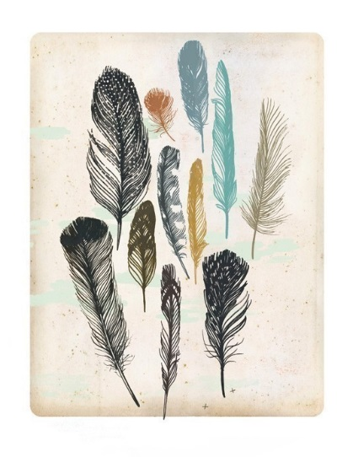](http://www.google.co.uk/url?sa=i&rct=j&q=&esrc=s&source=images&cd=&cad=rja&uact=8&ved=0ahUKEwjcu9jlyYvWAhVC0xQKHajuC-0QjRwIBw&url=http://shelleysdavies.com/light-as-a-feather/&psig=AFQjCNFC-eMwZOuin1vMff1PUOpvf6MDSg&ust=1504616051799946) [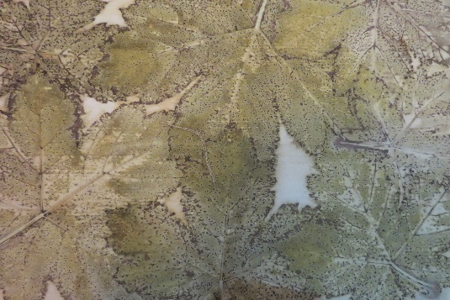](https://www.google.co.uk/url?sa=i&rct=j&q=&esrc=s&source=images&cd=&cad=rja&uact=8&ved=0ahUKEwitgpfAyYvWAhVJNxQKHXG0BCQQjRwIBw&url=https://carolinebelltextiles.wordpress.com/category/dyeing/&psig=AFQjCNGrUxlNUTc7mha8im9rzR3mFcnQrA&ust=1504615795499810)