different types of line drawing
1. Continuous line drawing
Continuous line drawing is a special kind of line drawing where the pencil stays on the paper from the beginning of the drawing to the end. This exercise forces you to draw lines in places you wouldn’t have otherwise. This adds an interesting almost abstract effect to continuous line drawing.
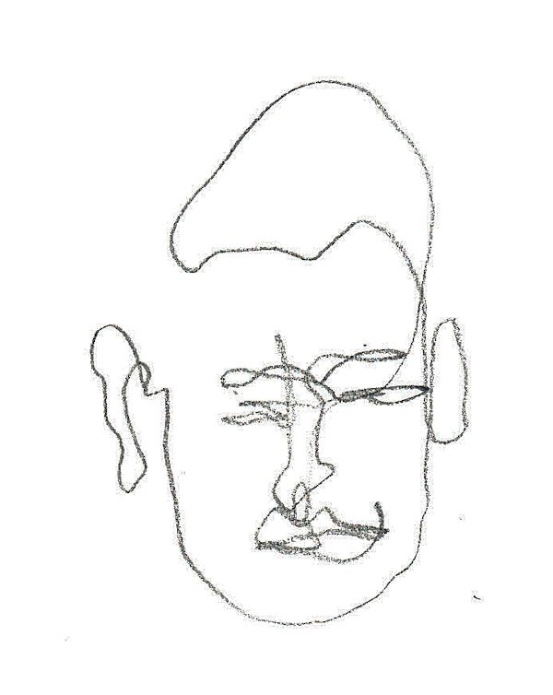
2. Blind continuous line drawing
Another type of line drawing is blind line drawing. This is an exercise that can feel rather counter-intuitive, as the artist is drawing the outline of a subject without looking at the paper. Blind line drawing takes the pressure off of making a good drawing since you know the result will probably look silly, but that’s what makes it fun! Focus is on the process, not the result. This is also a very good exercise to improve your eye-hand coordination.
Blind line drawing will also train you to spend more time looking at your subject than looking at the paper, which is always a good thing since many artists tend to draw what we think we see and not what we really see. There’s a natural tendency to look too much at the drawing on the paper and not enough at the subject. Blind line drawing also helps you to focus on the details since it forces you to work more slowly and spend more time observing the subject. If practiced regularly, you will start to see improvement in your blind line drawings.
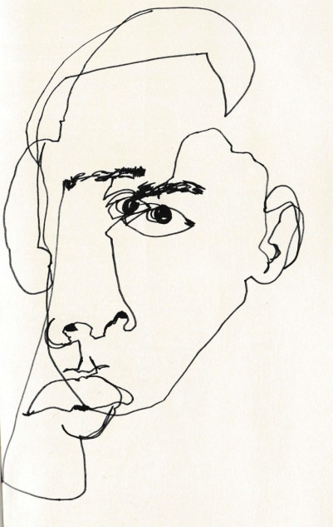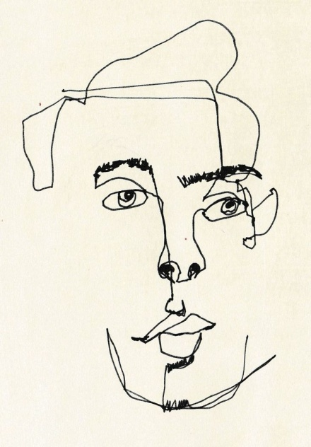
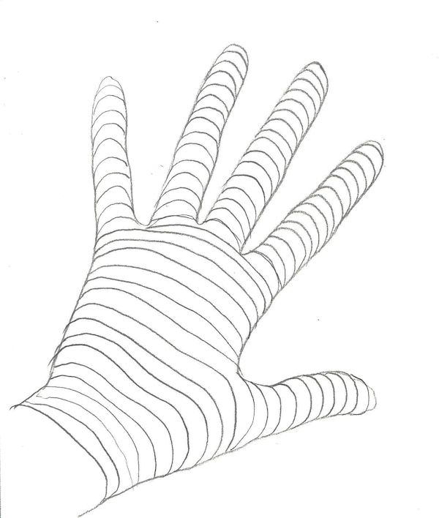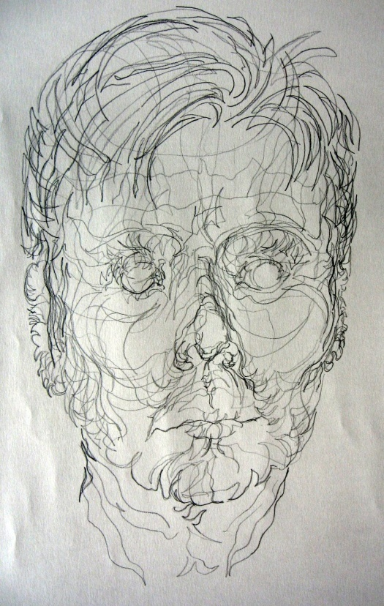

3. Cross-contour drawing
In cross-contour drawings, there are lines inside the object that suggest the 3-dimensions of the subject. Start by a regular contour drawing, drawing the outline of the subject, then draw lines inside the subject to suggest its form/shape.
Wire sculptures actually often look like cross contour drawings.

4. wrong hand drawing
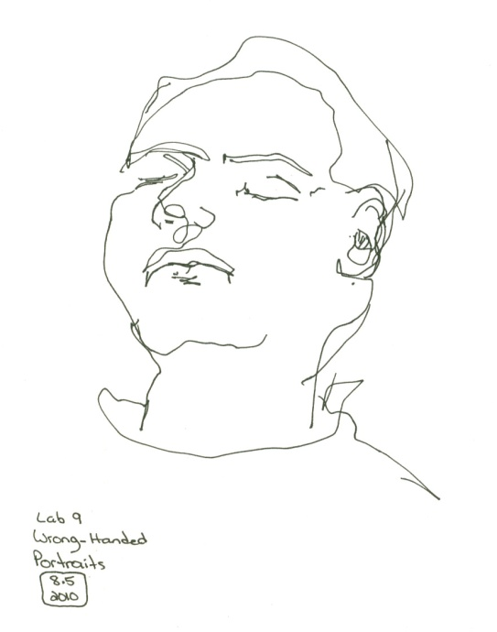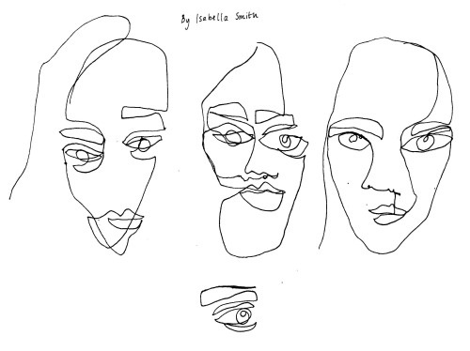

5. contour/LINE drawing to music
Keeping your drawing material on the paper, allow the line drawn to move in time with the music, and the way it makes you feel.

Drew Tyndell
  - The Portland-based artist grew up with an architect father, pursued graphic design in college.
  - His work walks the line between sculpture and painting, using colour and collage to create depth and space. You can even see how the shapes could be animated to move like puzzle pieces on a screen, similar to the looping animation work for which he’s also known.
  - Medium: Illustration
Location: San Francisco
Date: 2015
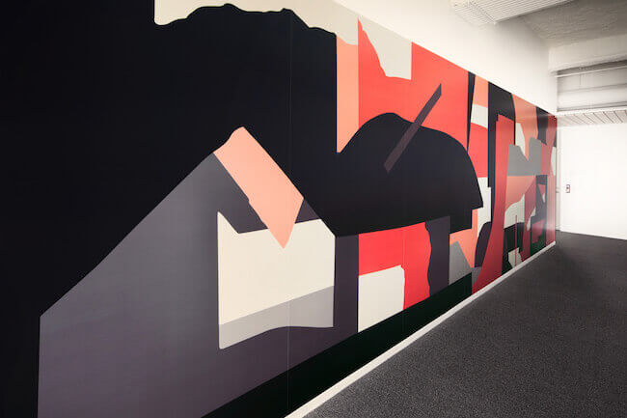
  - He created a contour drawing piece for Dolby®, but drawing upon music as his guide. “I really wanted my piece to respond to sound as much as possible. I wanted to use music to inspire the mark making in order to create shapes I wouldn’t normally draw,” Tyndell explains. So while listening to a combination of classical music and Philip Glass’s “weird looping pieces from the ’70s,” he created the shapes, lines, and counterforms blindly, then pieced them together for the mural. “I can’t say I've ever really shut my eyes and tried to listen to music as carefully as I did for this project. It was fun to bring that into how I create shapes … this project inspired me to create more organic shapes. My work is normally much more geometric. After I finished this project, I have been much more interested in mixing in more irregular shapes into my work.”

6. using line to show planes
Lines can suggest the surface and planes of your subject, adding depth and dimension.
Energetic and loose pencil strokes are dynamic and interesting. 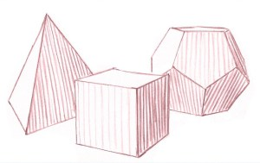One way of using line direction to show the orientation (direction) of the planes of your subject, is to make your shading lines in the same direction that water would flow if it were on the surface of the object. The direction of these lines change when you come to a new plane, except in the case of vertical planes (all vertical planes have vertical lines as in the cube). A change in plane also means a change in value (dark to light). The more abrupt the change in light and dark, the sharper the edge between two planes.
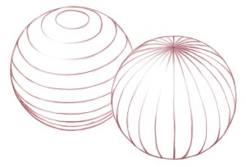
You can also use line-work to suggest a sphere. Use latitude or longitude lines to suggest a spherical shape. Study the way the ends of these lines tuck around the back side of the sphere.
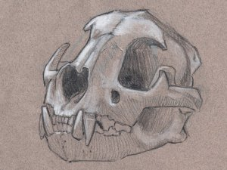 John Muir Laws
On this mountain lion skull, notice how the direction of the linework and changes in shading value suggest changes in the planes of the skull.

7. using line to create multiple overlapping

8. using line for abstraction
