THE USE OF LINE
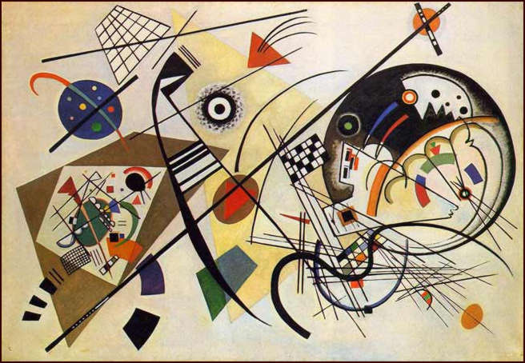 |  |  | 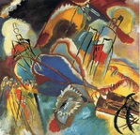
"Kandinsky was trying to create the same effect on a viewer of his paintings as a beautiful piece of music has on a listener. When you listen to Vivaldi’s Four Seasons, for example, you don’t see snow or swirling fall leaves, or a muddy spring garden after a rain storm. You feel the seasons happening but you don’t actually see them. This is what Kandinsky was trying to do in his paintings...
In terms of art, line is considered to be a moving dot. It has an endless number of uses in the creation of art.
Line can control a viewer's eye. It can describe edges. It can indicate form as well as movement. It can also indicate value and a light source in drawing. A simple way of thinking of a line is to imagine a point that moves...
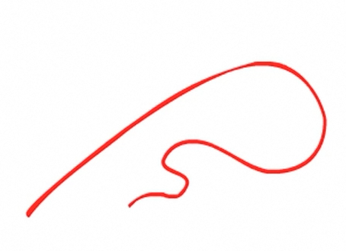
A line can be as simple as an ‘outline’ drawing of an object/

Line can also create the illusion of form in a drawing. Line quality is the thickness or thinness of a line. By varying the line quality an artist can show form in a drawing with just the use of line.
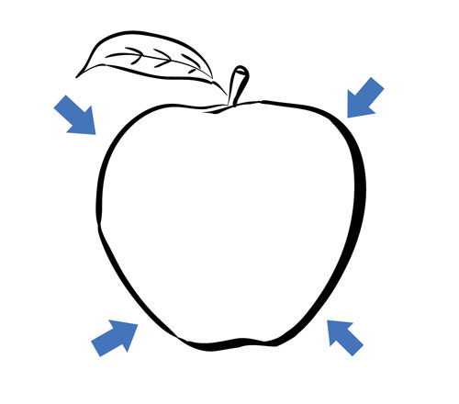

Line can also indicate shadow and form through the use of cross contour lines. Cross contour lines follow the contours of the object. Much like running your finger around the form of an object.
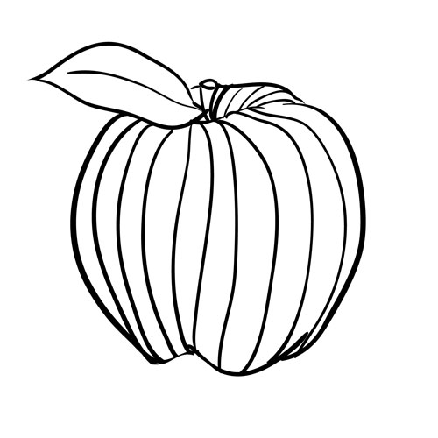

Showing planes with line angle
Lines can suggest the surface and planes of your subject, adding depth and dimension.
Energetic and loose pencil strokes are dynamic and interesting. 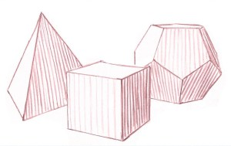One way of using line direction to show the orientation (direction) of the planes of your subject, is to make your shading lines in the same direction that water would flow if it were on the surface of the object. The direction of these lines change when you come to a new plane, except in the case of vertical planes (all vertical planes have vertical lines as in the cube). A change in plane also means a change in value (dark to light). The more abrupt the change in light and dark, the sharper the edge between two planes.

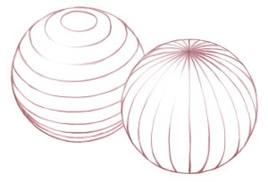
You can also use line-work to suggest a sphere. Use latitude or longitude lines to suggest a spherical shape. Study the way the ends of these lines tuck around the back side of the sphere.

TYPES OF LINES

Vertical lines - lines that move up and down without any slant
Horizontal lines - lines that are parallel to the horizon
Diagonal lines - lines that slant
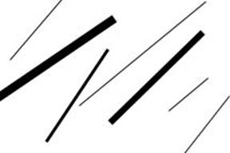
Zigzag lines - lines made from a combination of diagonal lines
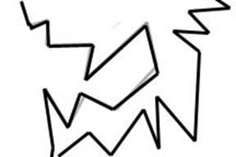
Curved lines - Lines that change direction gradually
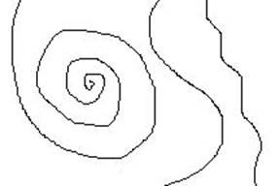
Line Variation - adding interest to your lines is important in creating successful artwork
Length - lines can be long or short
Width - lines can be wide or skinny
Texture - lines can be rough or smooth
Direction - lines can move in any direction
Degree of curve - lines can curve gradually or not at all
Line quality or line weight - refers to the thickness or thinness of a line. By varying the line quality artists can make objects appear more 3-Deminsional and more interesting
Hatching and crosshatching - using lines to create value
Hatching - lines going in the same direction
Crosshatching - lines that cross
https://youtu.be/BDePyEFT1gQ
Painters use line to outline shapes and create perspective, among other things. But there is also a theory that suggests various emotional states can be inspired by different types of lines in art. For example, a horizontal line supposedly conveys restfulness, since it mimics the position of a body in repose; a vertical line supposedly conveys spirituality, because it infers height; mixed horizontal and vertical lines supposedly convey stability; diagonal lines supposedly convey motion; and curved lines supposedly convey humanity and sensuality.
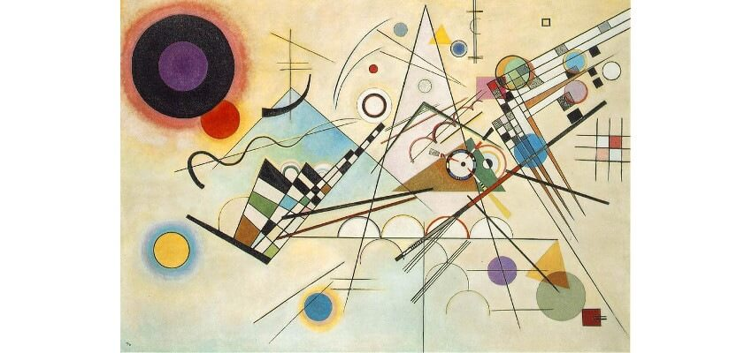
Wassily Kandinsky - Composition VIII, 1923, oil on canvas, 140 x 201 cm

In 1926, after testing his theories, Kandinsky stated his belief in the emotional impact of line in art.
The paintings he created around this same time can be read as demonstrations of his theories.
They use line formally to outline shapes, create dimensional forms, and to create perspective, and also to inspire emotional effect. An iconic example is the painting Composition VIII, which is admired for its sense of harmony and compositional balance. In it, crossed horizontal and vertical lines in the lower frame provide a stable foundation for the composition. Multiple diagonal lines create movement toward a vanishing point in the upper right. And curved lines introduce a lively, biological presence.

Egon Scheile and line
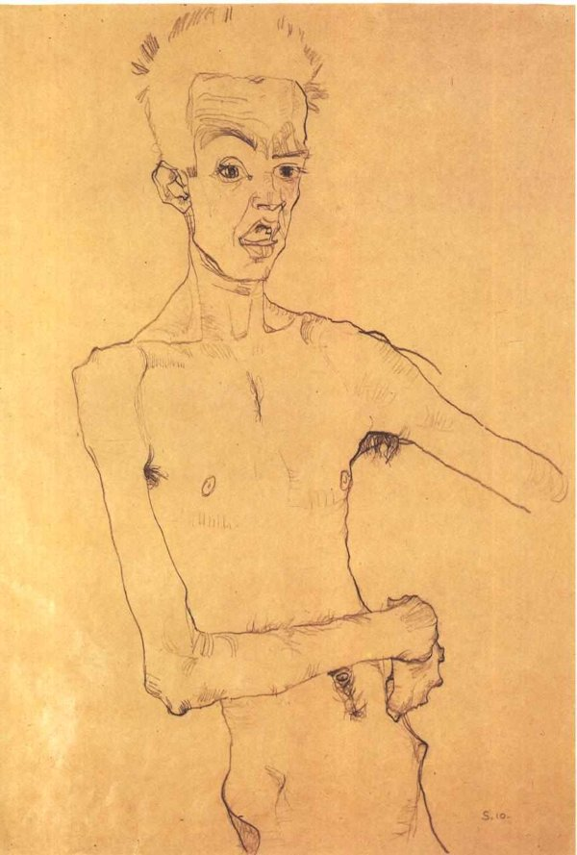
Egon Schiele’s Self Portrait (1910)
In French, the word contour means “outline.” Contour drawing is exactly that, an art technique that consists of drawing the outline of a subject.
Schiele was a major figurative painter of the early 20th century. His work is noted for its intensity and its raw sexuality, and the many self-portraits the artist produced, including naked self-portraits. The twisted body shapes and the expressive line that characterize Schiele's paintings and drawings mark the artist as an early exponent of Expressionism.
Contour drawing can be one of the first steps in creating a painting, but on its own, contour drawing can be a simple, elegant and expressive art form. Almost like handwriting, every artist who practices contour drawing for a long time will develop his or her own unique style. Austrian painter Egon Schiele, whose self-portrait is seen above, is known for creating contour line drawings that are a bit twisted and very expressive
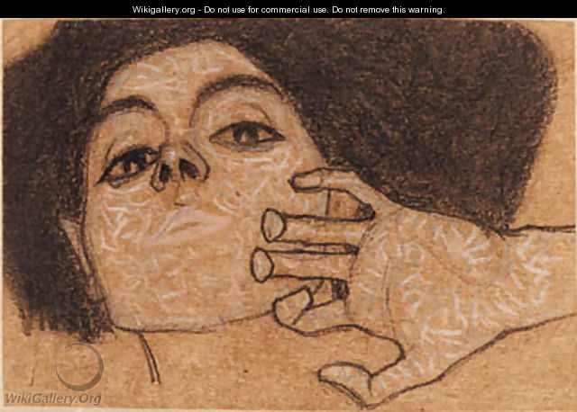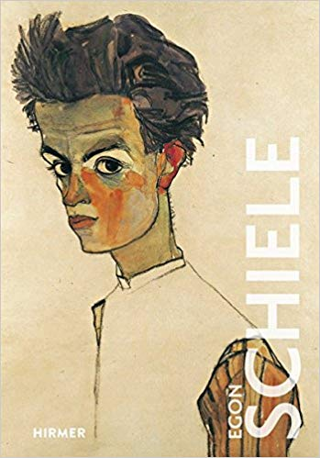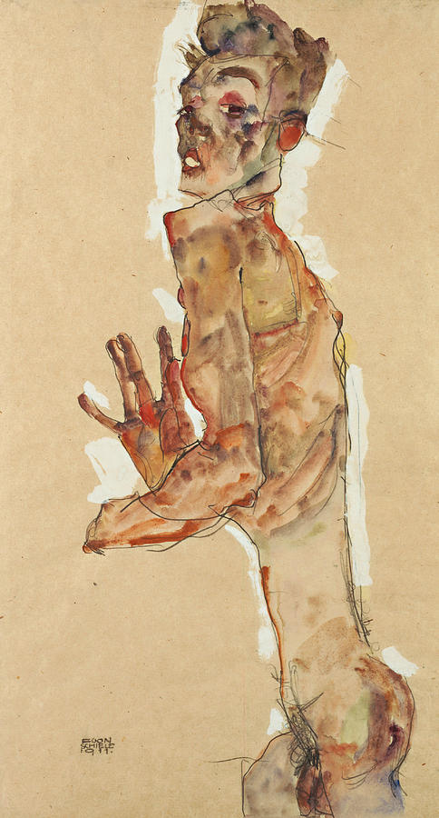
Egon Scheile had an extraordinary ability to form the three dimensional body through dominating contour lines, using very strong colours and often ambiguous spaces. His paintings showed extraordinary sensitivity, which transforms even a quick drawing into a complete work of art.
To make a contour drawing, you have to focus on edges, but that doesn’t mean that you can’t draw anything else other than the outline. Edges can also be found inside the subject in changes of color, shades, folds and details. For example the finger creases can be seen as edges and drawn in a hand contour drawing.
The line describing the contour can show variations to make it more expressive. It can also vary in weight and darkness to make the contour drawing more interesting. You’ll notice such variations in Egon Schiele’s work.

Pablo Picasso and line
The simplicity, energy and life captured in Picasso’s line drawings perhaps explains the continued popularity of these images. At first glance we all think we could easily replicate these images but to use so few lines to express so much is a lot harder than it looks and is testament to Picasso's artistic talent.
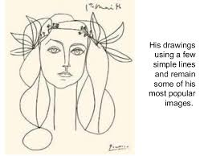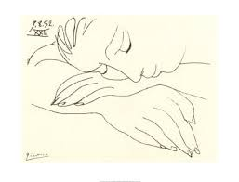
Sleeping Woman By Pablo Picasso; Lithograph; 21 x 21,5
It was the influence of primitive art in the early 20th century with its simple styling that led Picasso to create simpler line drawings in his later years. Looking at his work The Bull you can see how he worked away at the complex image bit by bit reducing it to a single fluid line that still posses all the power of the bull itself. His single line drawings are so simple but at the same time so powerful as they create so much using a single unbroken line.
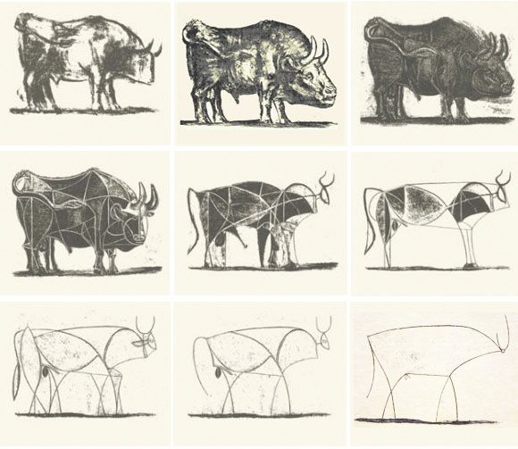
Picasso loved animals and kept a huge variety over his life-time many of which appeared in his work, and in particular his line drawings. He formed a particular attachment to a dachshund called Lump. Lump was immortalised in Picassos drawing.
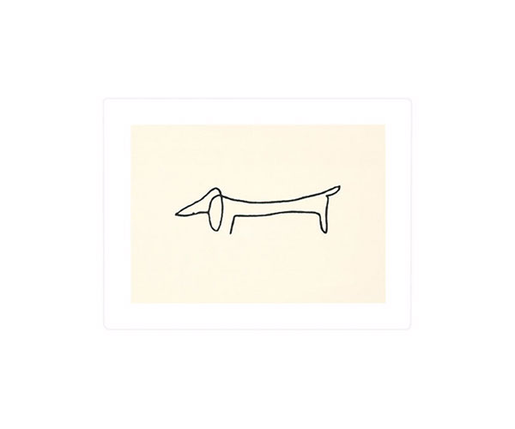
Watch you tube video: Picasso the line
https://www.youtube.com/watch?v=OrPwBPwqI3Y

