- Use of the student line drawings of collected personal items in jam jar. Choose abstract, simple shapes from continuous line drawings, to draw onto, and cut out of flexible card. Look at the abstract and simplified 3D sculptural forms of Barbara Hepworth.
Task: students to use the shapes cut out of card, to fold, bend and manipulate, and bound in place with string lacing to create Barbara Hepworth influenced 3D sculptural maquettes.
Homework: Further research and sketches on the sculptures of Barbara Hepworth.

- Student exploration of string and glue to create 3 dimensional linear forms based on the continuous line drawings they have completed from their personal items.
Students will place clear acetate on their line drawings, trace their studies on the ascetate with string dipped in PVA, and the bent / twist the acetate to create a 3 dimensional shape. This will be held in place overnight until the glue dries. The acetate can then be removed to reveal the linear string sculptural forms.
Reference should be made to the simple wire sculptures of Alexander Calder.

- A look at the sculptural head and torso work of Naum Gabo. Students will complete continuous line drawn portraits by observing themselves in a mirror. They will be asked to complete a number of tasks to explore abstraction of shapes eg drawing with wrong hand, blind continuous line studies. Overlapped studies from several angles.
From these studies students will design their own Naum Gabo influenced head, considering form, space, and cross sections.
Students will solve construction problems by attempting to create a 3 dimensional version of their final design out of flat pieces of card.
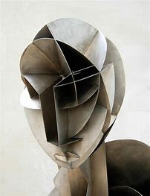
- Use of a range of mark making with a range of materials to create tonal areas and textures within the theme.
Bridging the gap between 2D and 3D: line drawing with wire based on the theme. Looking at the wire work of Alexander Calder/ Antony Gormley. Use of mark making (lines/cross hatching with wire to create shades).
Creation of and Antony Gormley inspired wire figure, as development from the previous Naum Gabo work on considering form, space, and cross sections. This ‘Gormley’ task is based on creating the feeling of ‘energy’ through experimentation of wire and wire manipulation.
Extesion task: Look at the figure sketches and metal figure casts of artist Alberto Giacometti. Consider how ‘loose’ the sketches are, ‘stretched’ ‘abstract’ and ‘lively’. Your task is to consider these key word when developing your own Giacometti wire figure. You are limited to using a range of wires, a set of wire cutting pincers, and pva glue. How you manipulate, bind, fold, attach the wire and glue is your choice through experimentation.

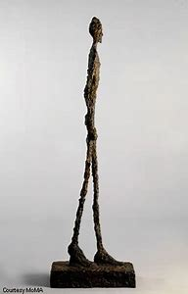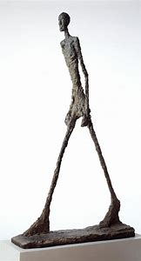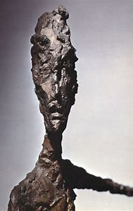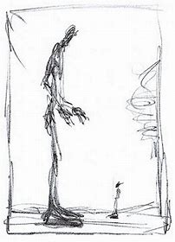

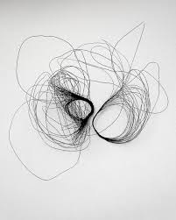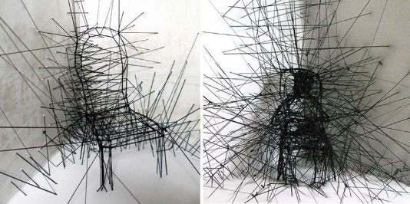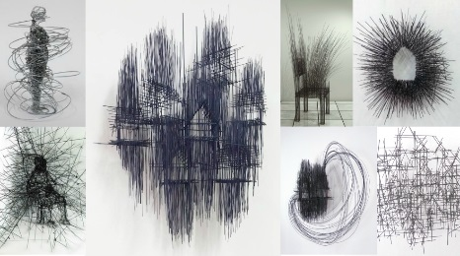

- Bridging the gap between 2D and 3D: Working in relief with a range of raised materials to create tone and textures. Focussing on use of a viewfinder to ‘zoom in’ on a section of their work. Materials include string, wool, thread, bamboo, sand, salt etc
- Using the contemporary artist Tim Chandler (Mixed media plaster and acrylic paints and stains) .
Sculptural relief work with poly-filler. Production of a range of mark making and textures to enhance the ‘mood’ of work.

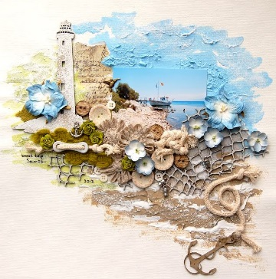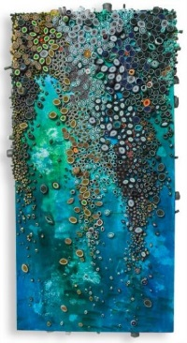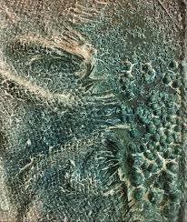

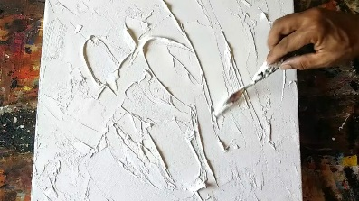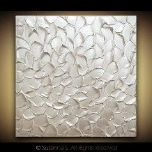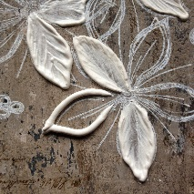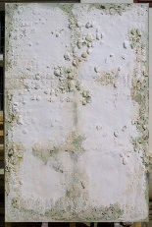

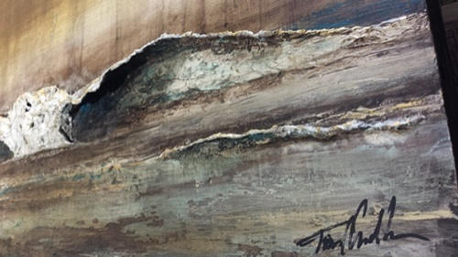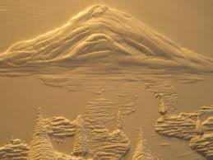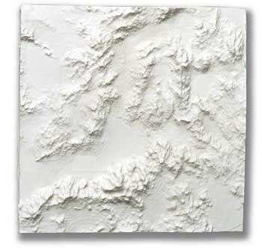

List of 3D tasks
- Explore the work of David Moreno – discuss light and Dark (chiaroscuro) 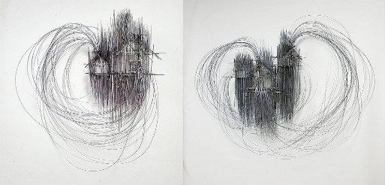 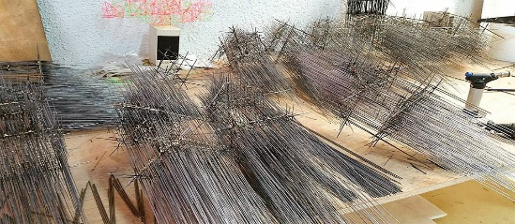
Complete a series of sketches of the environment (in his style).
Experiment and explore wire structures based on the sketches.

- Explore the work of Richard Sweeney – discuss light and dark (chiaroscuro) and shadows.
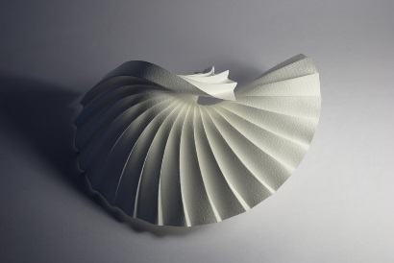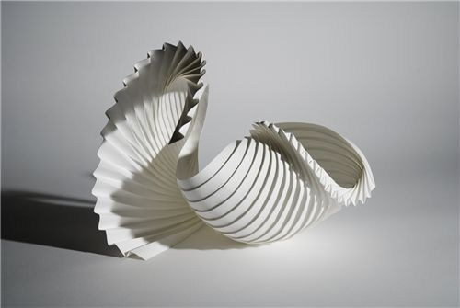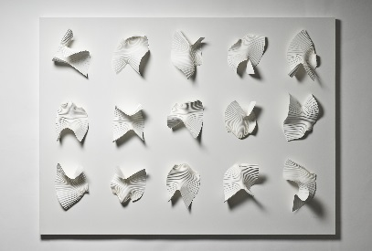
Take photographs of stairwells/ curling leaves/ flower petals in immediate environment.
From these photographs, experiment and explore with paper folding to create Richard Sweeney influenced abstract 3D shapes.

- Look at textures in the immediate environment eg rust, mold, relief signs, wallpaper, relief manhole covers etc
Explore these through rubbings, embossed prints (relief pattern on fire escape signs/manhole covers), casts (pushing clay onto surfaces, mod rock casts), pouring slip/plaster/concrete into shallow casts of textures. Artist Rachel Dein.
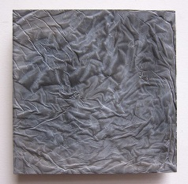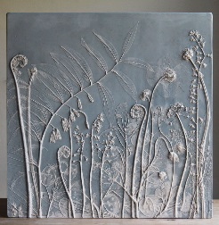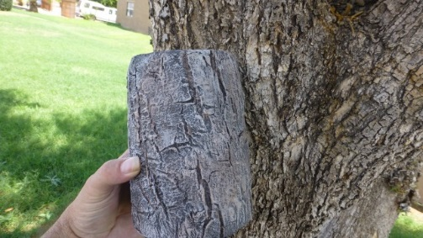
Recreate textures through mixed media experimentation eg rust, mold, speckles on leaves etc.
Build textured clay tile slabs based on found textured in the environment – artist Chris Gryer
