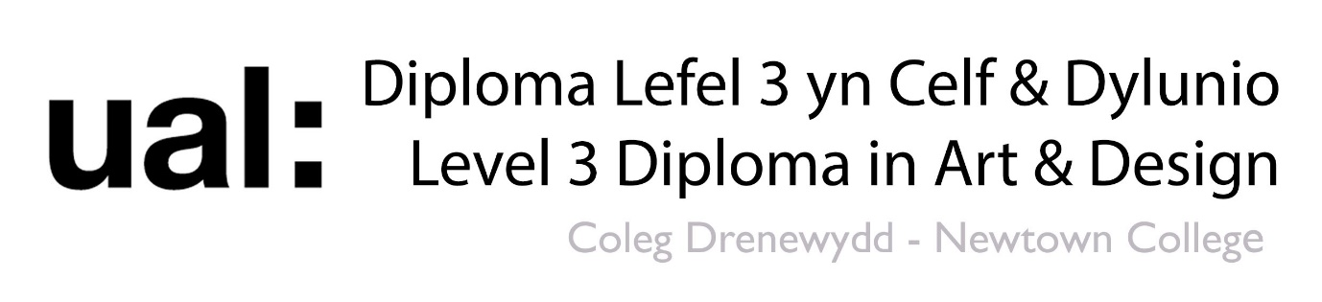

Reflect and Review

In your opinion, what is your strongest work in this project so far?

Explain why you think it was successful.

How can you improve on this technique in future work?

What mood dose this work communicate to an audience? How does it do this?

In your opinion, what is your weakest work in this project so far?

Explain why you think it was unsuccessful.

How can you improve on this technique in future work?

What mood dose this work communicate to an audience? How does it do this?

