Mixed media
Mixed media is a term used to describe artworks composed from a combination of different media or materials
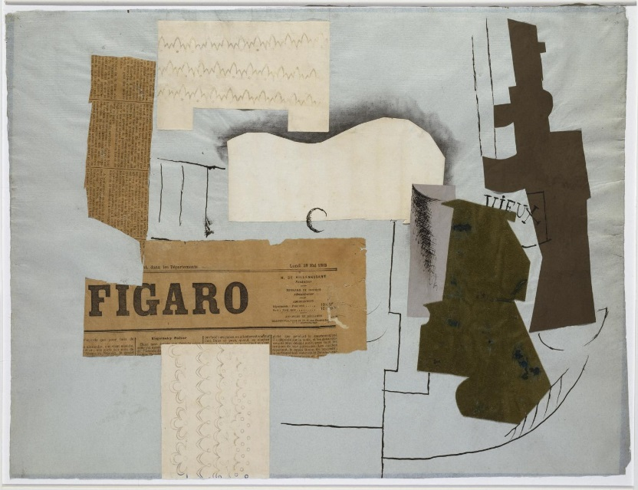
Pablo Picasso
Bottle of Vieux Marc, Glass, Guitar and Newspaper 1913
Tate

The use of mixed media began around 1912 with the cubist collages and constructions of Pablo Picasso and Georges Braque, and has become widespread as artists developed increasingly open attitudes to the media of art. Essentially art can be made of anything or any combination of things.
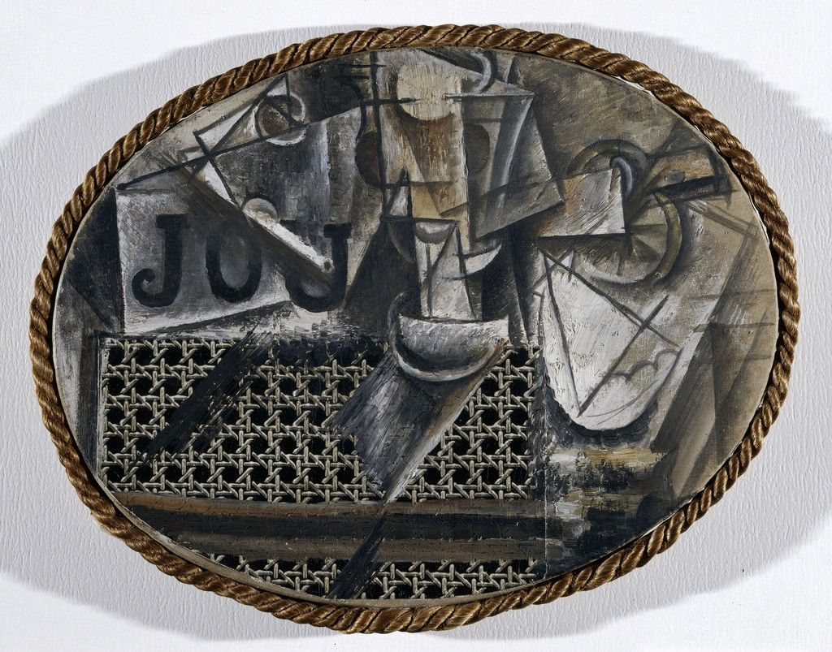

Pablo Picasso : Still-life with Chair Caning 1912 Musée National Picasso, Paris

Picasso’s Still Life with Chair Caning was arguably one of the first collage works by Picasso
the work is a small painted assemblage of the letters “JOU,” and there is also a pipe, a glass, a knife, a lemon and a scallop shell in the picture. These objects are augmented by the insertion of a strip of oilcloth onto the canvas
While the oilcloth alone signals that this is a revolutionary type of work, what would be called a collage or papier-collé, there is also another piece of material from the real world, a rope, which acts as a frame for the work.

Influenced by Cézanne to explore the further potential in analyzing the structure within painting, Pablo Picasso and Georges Braque began making works which would eventually be understood as Cubist.
During the Analytic period, Picasso and Braque progressively broke down three-dimensional objects into fragments—corresponding to an object’s appearance from various different viewpoints in space—until they came close to entirely abstract artworks.

At some point during 1911, Picasso and Braque became less concerned with painting as a description of multiple viewpoints or as a collection of shattered viewpoints
but instead in a new kind of pictorial construction and a new kind of art-making.

the idea that these new images were built-up rather than broken-down. Central to the ability of these works to build up elements was the invention of collage.

Collage was an extraordinary break with the past. Even though artists previous to Picasso and Braque had painted and drawn, etc. in their works, and even though artists previous to Picasso and Braque had occasionally used the method of collage, Picasso and Braque were the first well-recognized artists to do it intentionally and towards the purposes of artistic innovation.
Collage (like Cubism itself) was hugely influential. After word of Picasso and Braque’s new technique spread, just as with the birth of Cubism, a virtual torrent of artists (other Cubists, but also Futurists, Dadaists, and others) started working with collage. Importantly, Picasso and Braque should also be seen as the first artists to make mixed-media works (i.e. works made out of more than one medium)

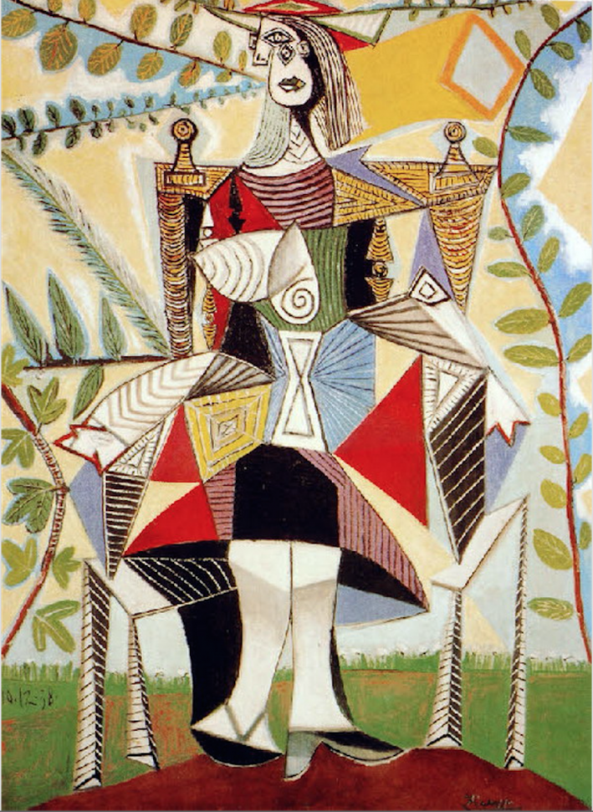

Pablo Picasso created the painting Femme au chapeau assise sur une chaise (Seated woman with a hat) in Mougins, France, on September 10, 1938. He gave form to the painting's figure by adhering coarse-grained sand to the primary wood panel support. He then applied color to the composition using fluid and glossy paints.

