TOILET ROLL COUTURE
As the country has been going crazy buying up lifetime supplies of toilet rolls, I thought you can all have a go at making a ‘wearable object’ using left over toilet roll tubes. This object could be a sculpture that is placed on the body / by the body or a piece of elaborate / simple / wearable jewellery (headpiece / ring / bracelet, earrings)? I look forward to seeing your ‘toilet roll chic’ outcomes. I would choose an image to work from, maybe look in the house, garden or on your daily walk for inspiration. Look at the colours and shapes that you can dissect from your chosen item / image to re-create in card.
It would be worth doing some experiments with card to see what you can do with it as seen in the below image. It can be used in many ways!!!
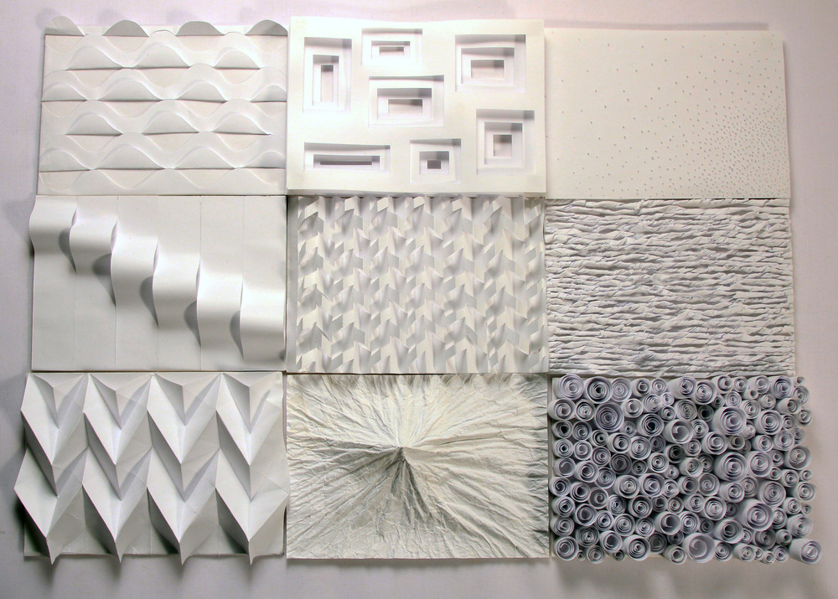

Here is my ‘Blue Peter’ style step by step images of how I have created my example for you. It has been inspired by a close up of a gerbera. It shows the neckpiece at differing points and how it has developed to show you that your outcome could be simplistic, yet still striking, or you can keep adding and adding until it is more OTT! I could have kept on going! It would be great if you could put together a document to show your progress. I had great fun making mine and it is amazing at how lushous a humble toilet roll can look. If you feel like you want to add elements of other recycled materials feel free, but make the toilet roll he main event!
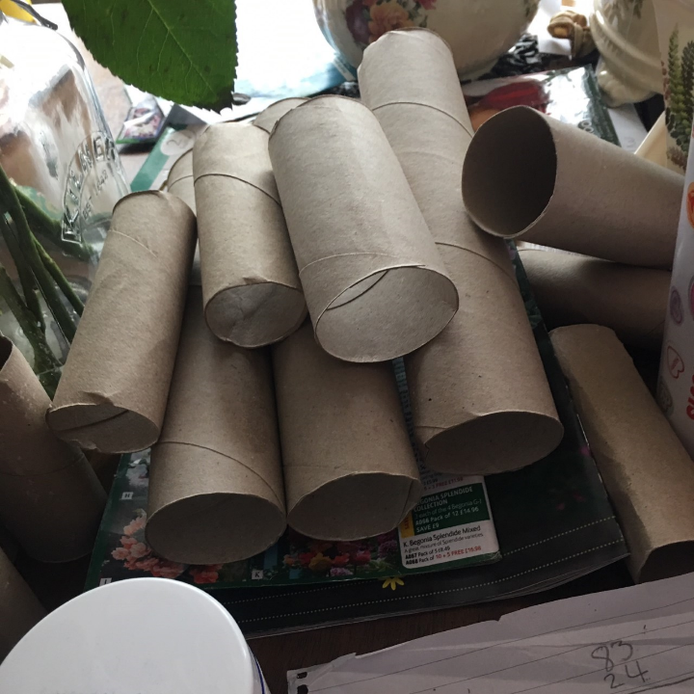
The chosen image My toilet roll stash

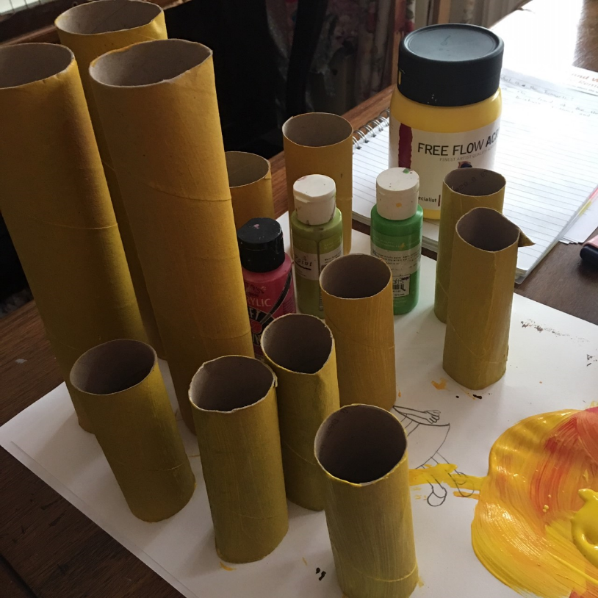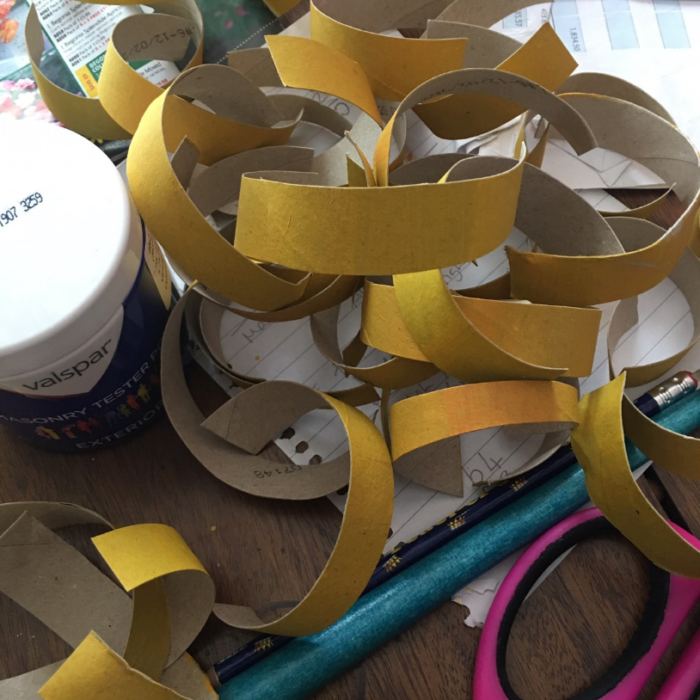
Painted toilet rolls yellow Cut the rolls lengthways then into strips to
create curled circles to chain together
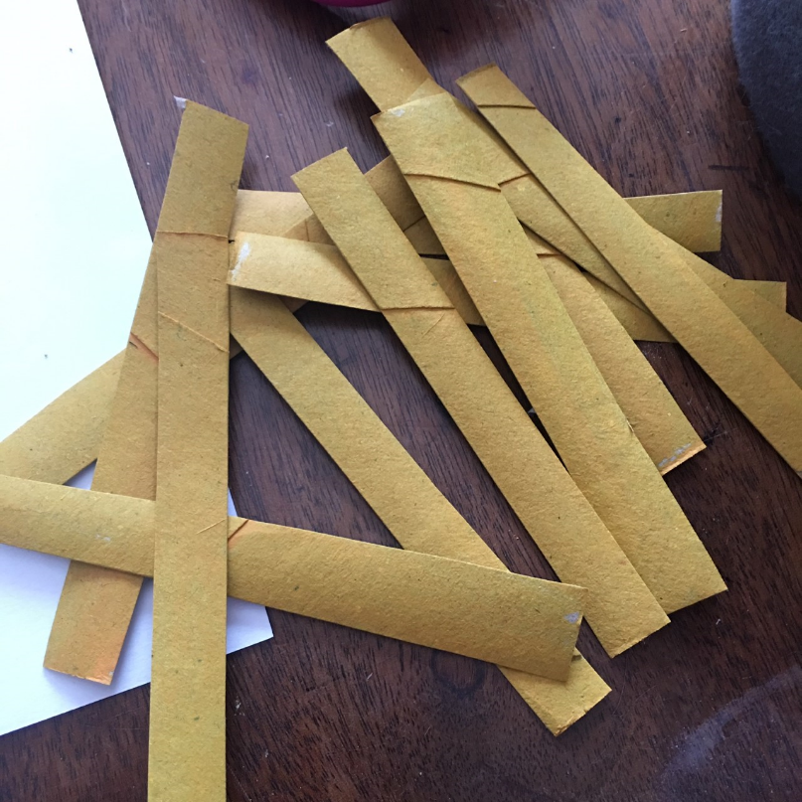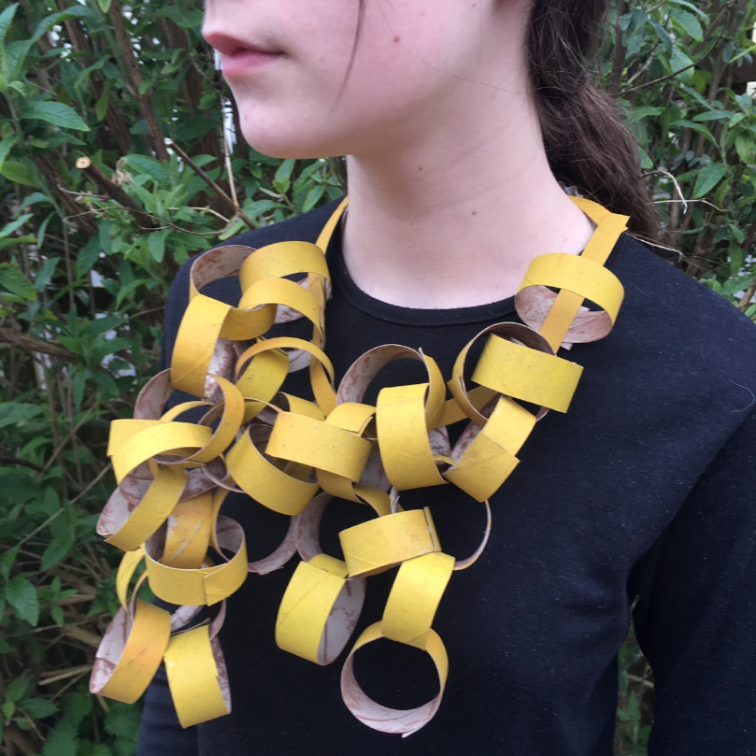
One toilet roll cut into strips lengthways to create the base to attach and link the curled circles onto

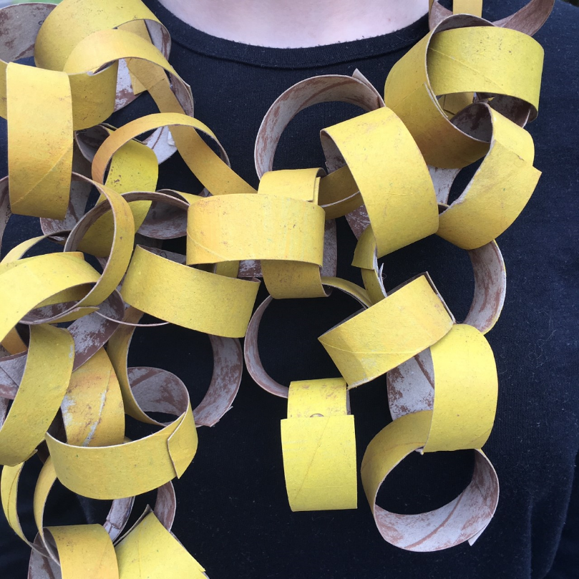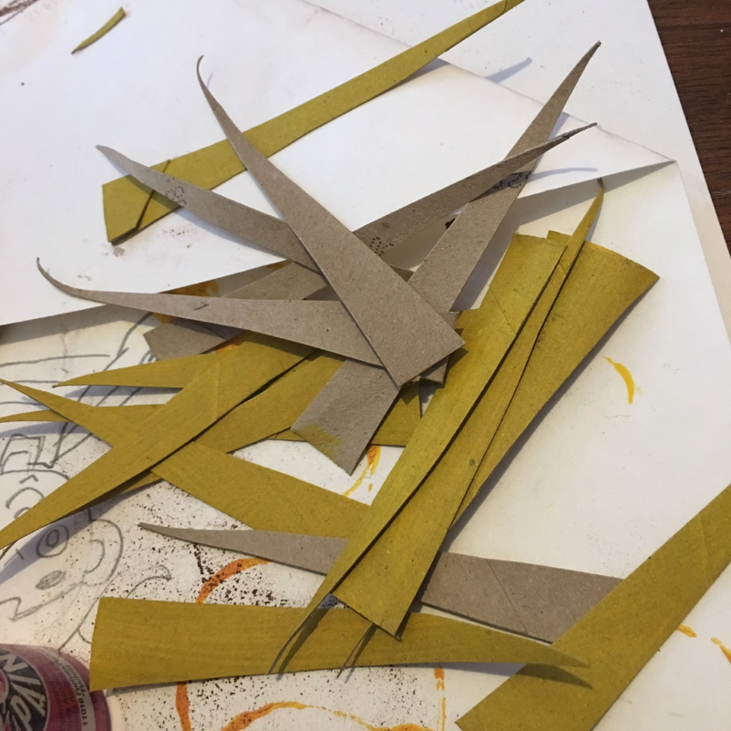
Cut long triangles to attach to my chain links
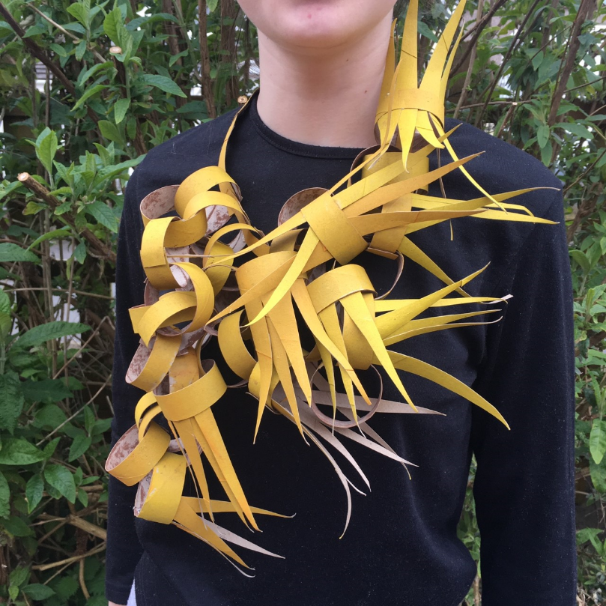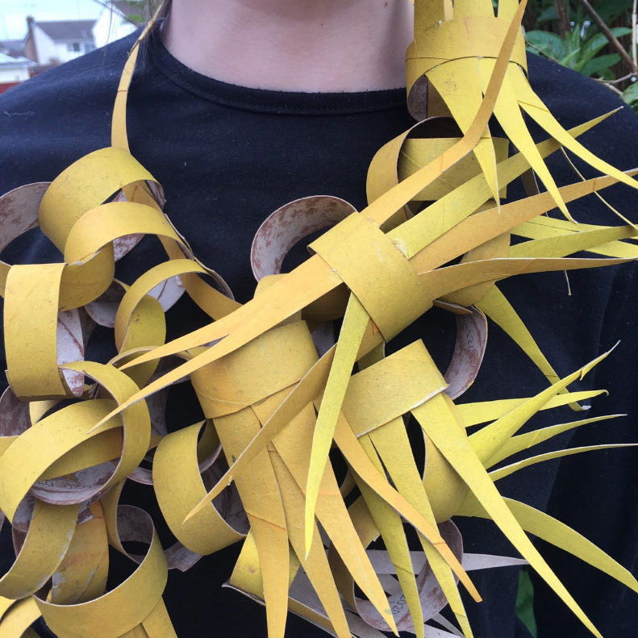
Close up of the added triangles linked to the spikey petals on the image

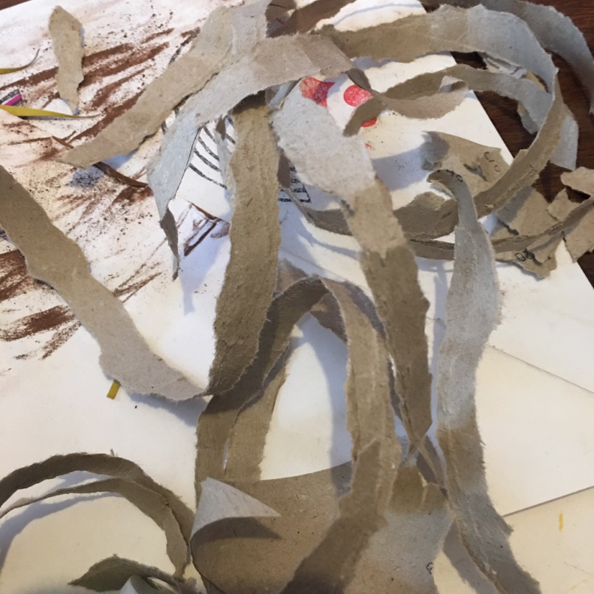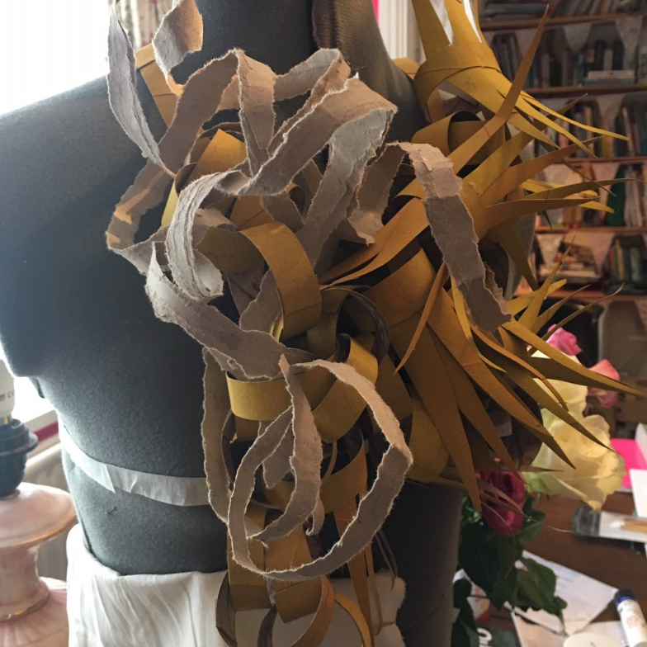
Hand ripped toilet rolls to create softer shapes but look too much added to neckpiece

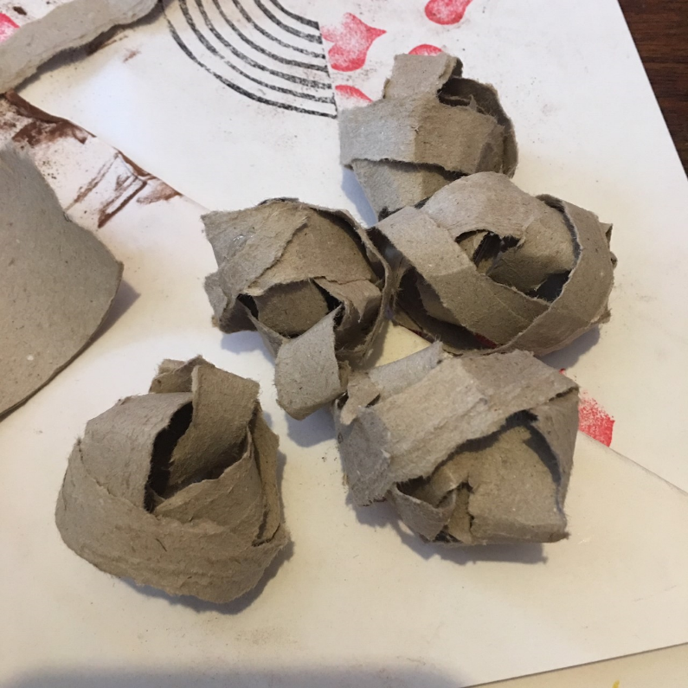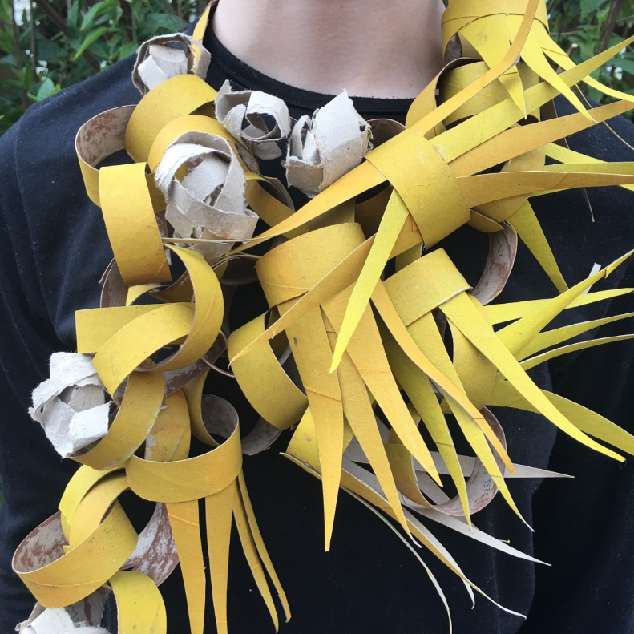
Rolled the ripped card into balls to represent pollen and attached onto neckpiece

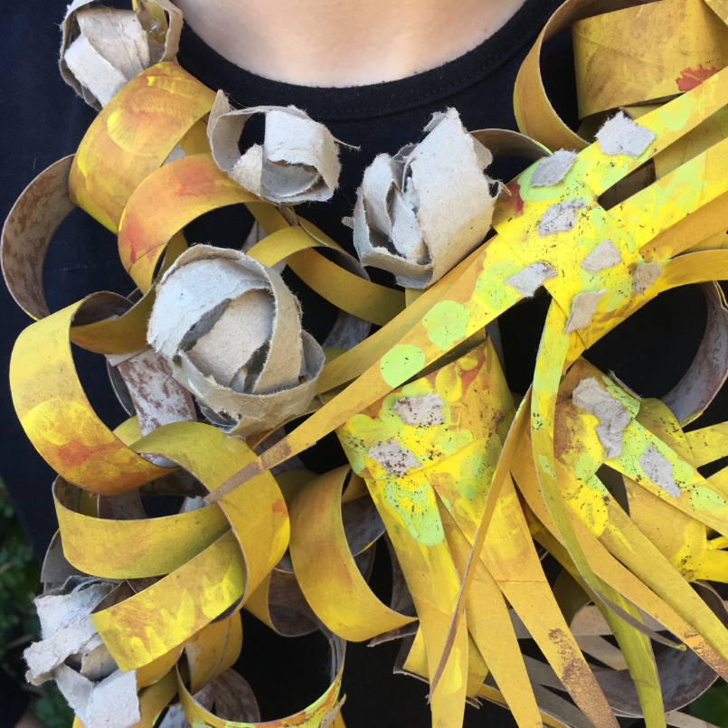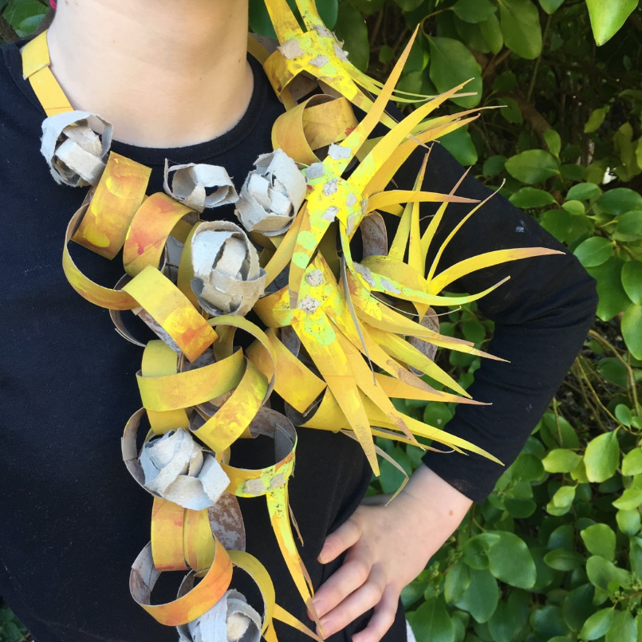
Added some paint and chalk pastel detail with added scraps of ripped card
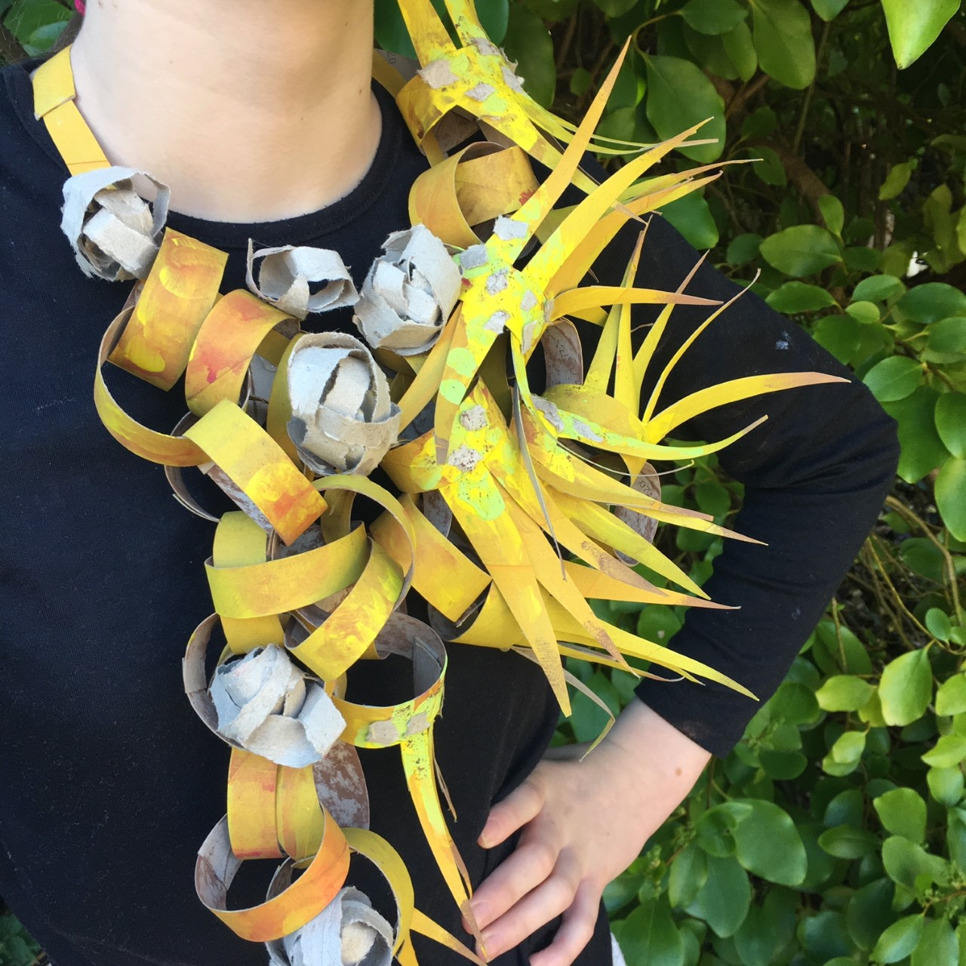
And here is the completed neckpiece

